**POC Azure Migration plan**

1. Discover and assess the on-premises environment
2. Migrate the Application Database
3. Migrate the application and web tiers using Azure Migrate: Server Migration

**Discover and assess the on-premises environment**

[Task 1: Create the Azure Migrate project and add assessment and migration tools](https://github.com/microsoft/MCW-Line-of-business-application-migration/blob/master/Hands-on%20lab/HOL%20step-by%20step%20-%20Line-of-business%20application%20migration.md#task-1-create-the-azure-migrate-project-and-add-assessment-and-migration-tools)

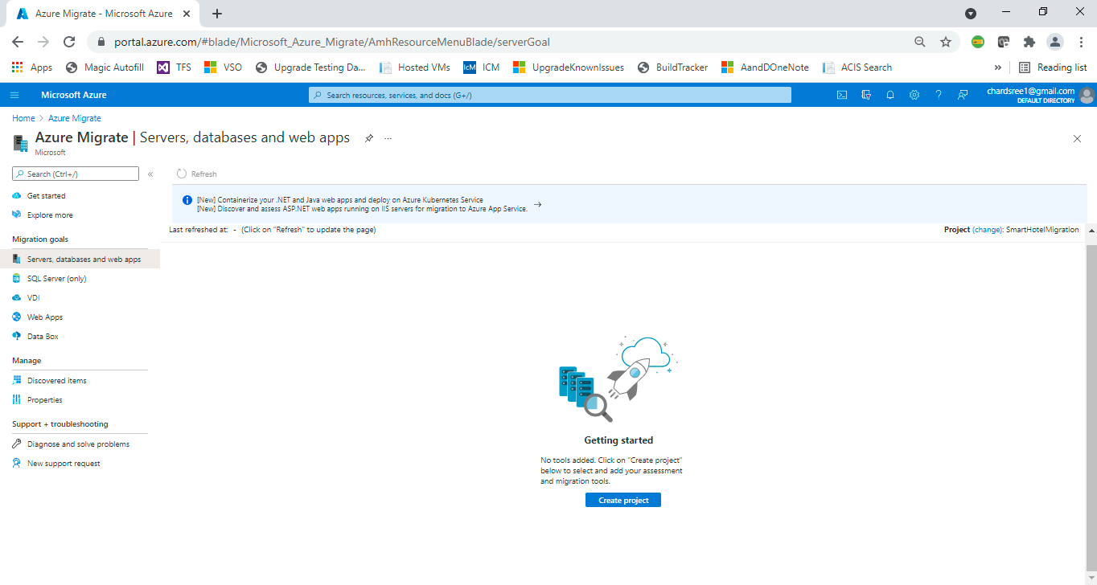

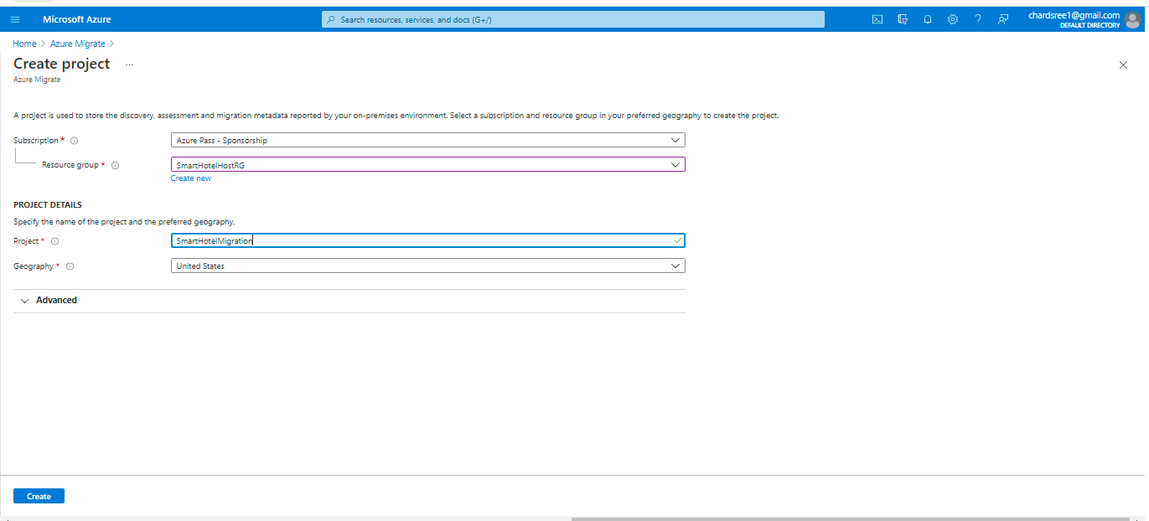

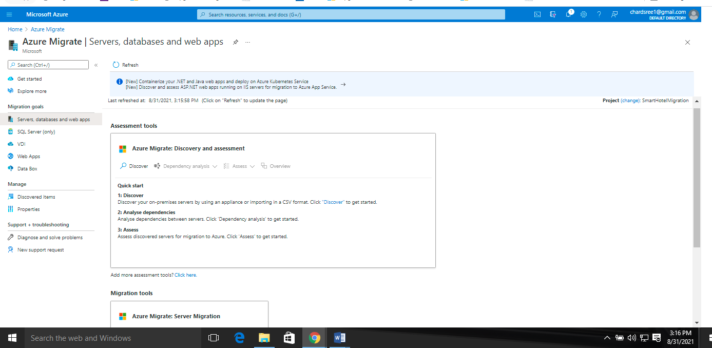

In this task you created an Azure Migrate project, using the default built-in tools for server assessment and server migration.

**Task 2: Deploy the Azure Migrate appliance**

Discover the machines using Discover option

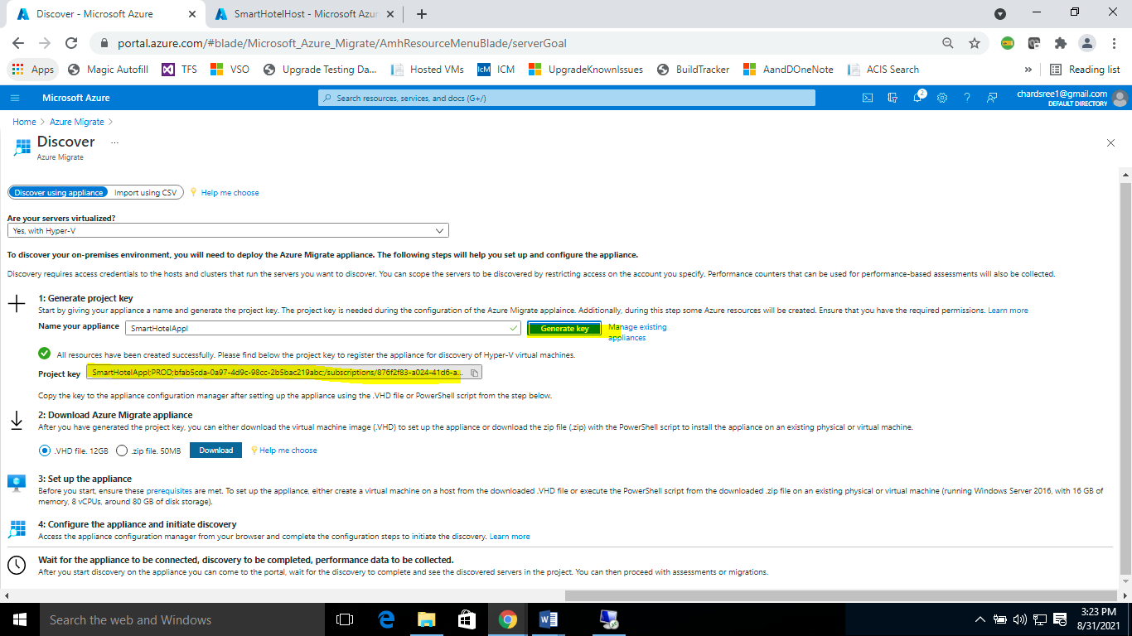

Copy the key to notepad

SmartHotelAppl;PROD;bfab5cda-0a97-4d9c-98cc-2b5bac219abc;/subscriptions/876f2f83-a024-41d6-aea2-668ba482efa0/resourceGroups/SmartHotelHostRG/providers/Microsoft.Migrate/MigrateProjects/SmartHotelMigration

Connect to SmartHotelHost and Import virtual machine application

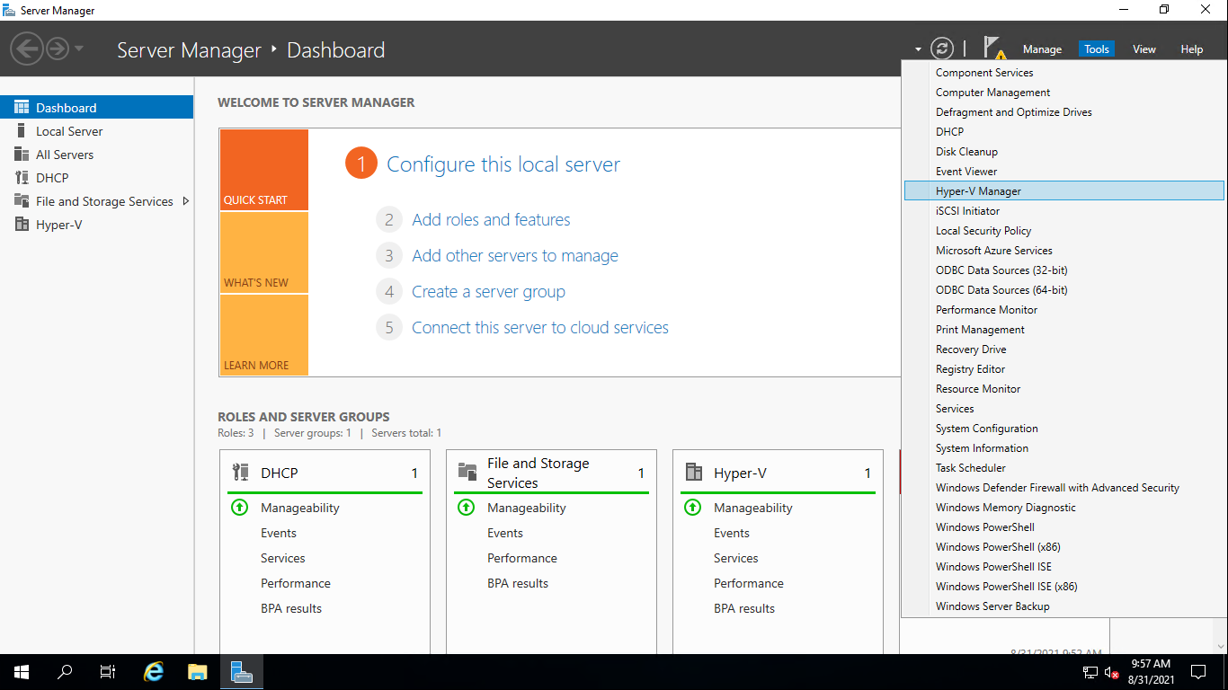

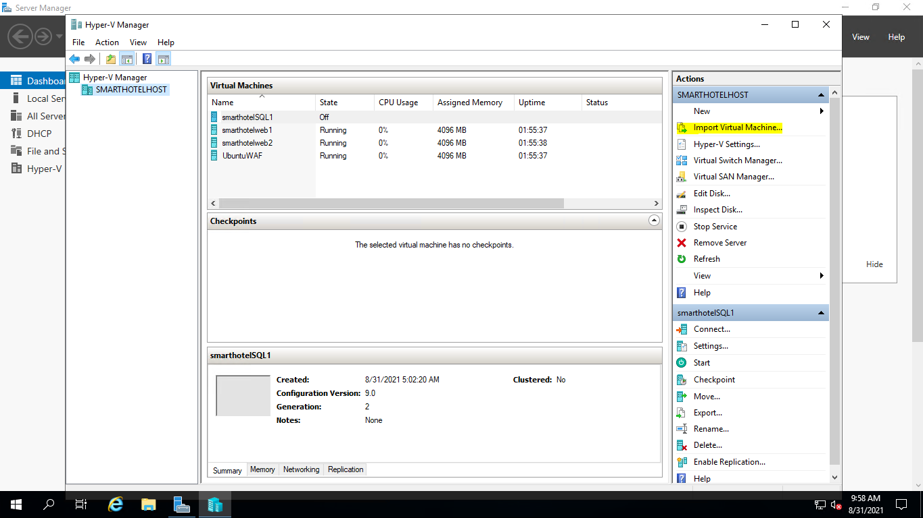

Proceed with importing

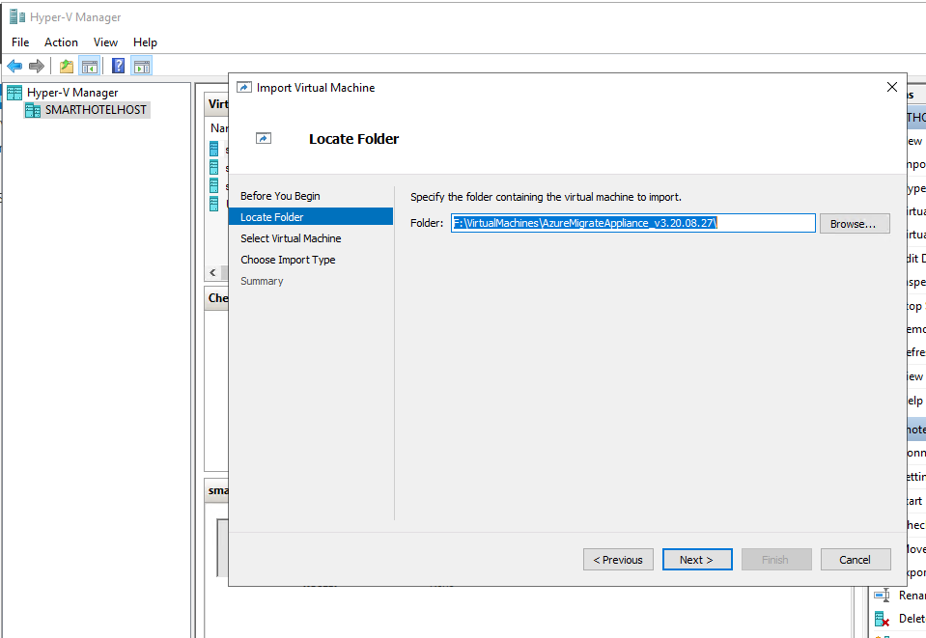

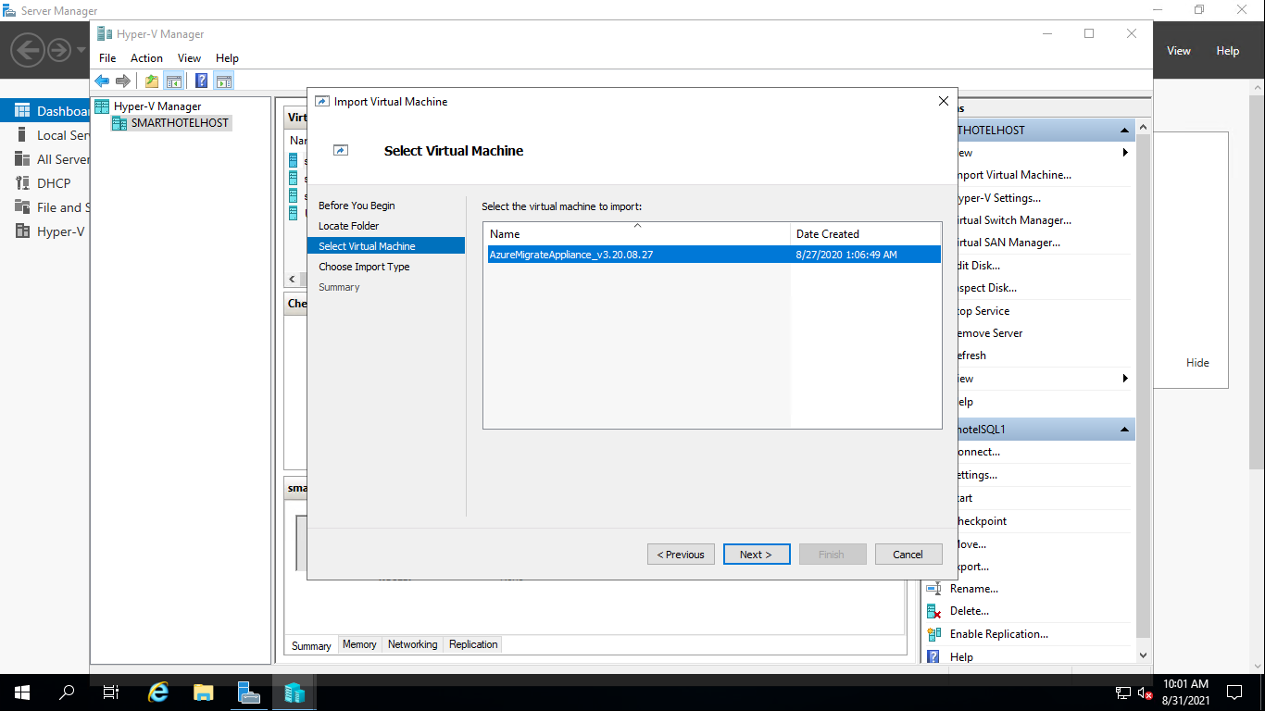

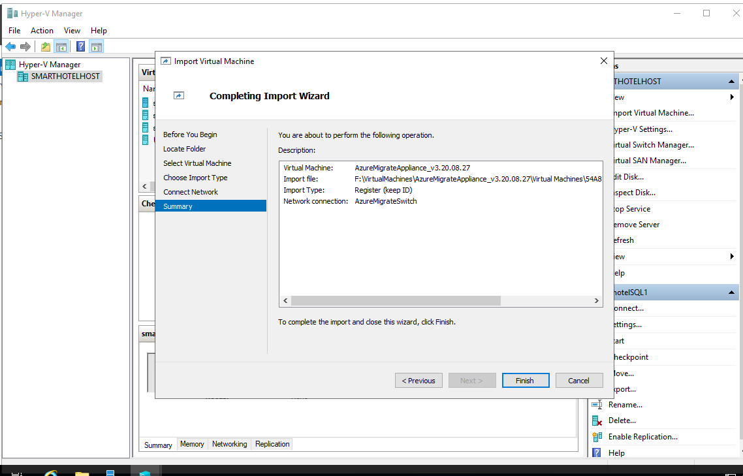

In this task you deployed the Azure Migrate appliance in the on-premises Hyper-V environment.

**Task 3: Configure the Azure Migrate appliance**

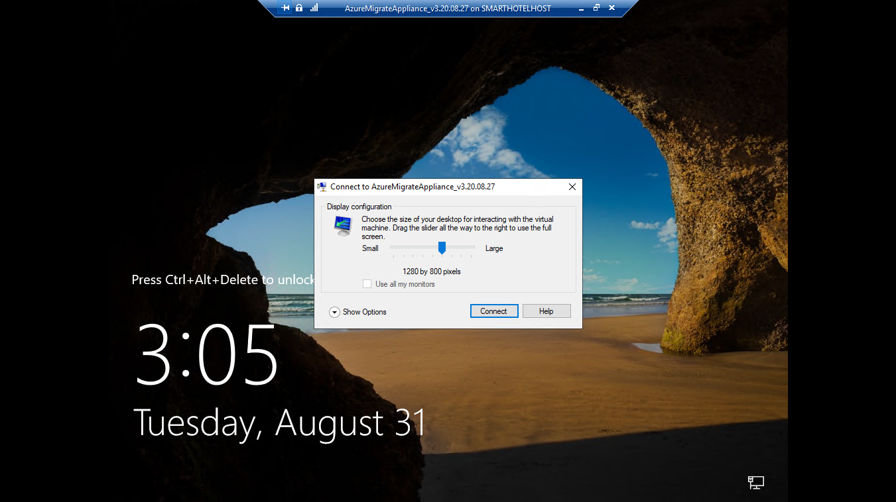

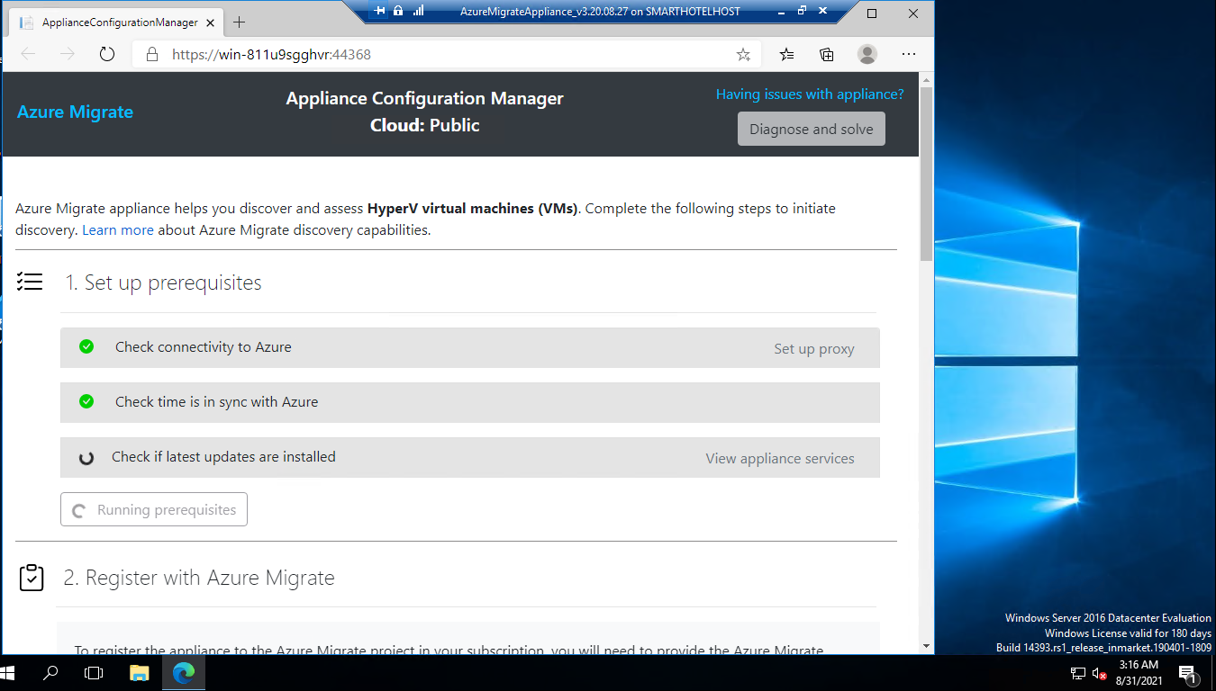

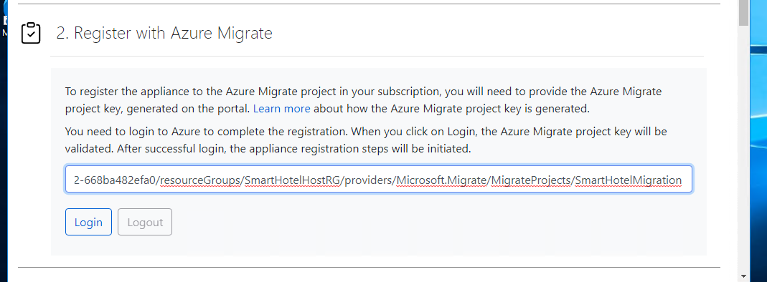

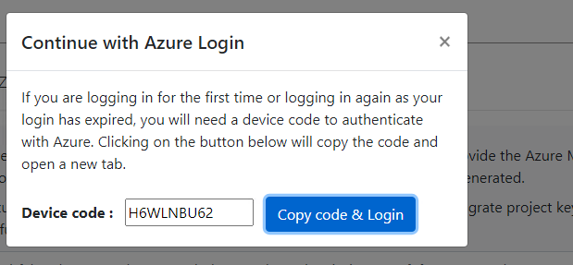

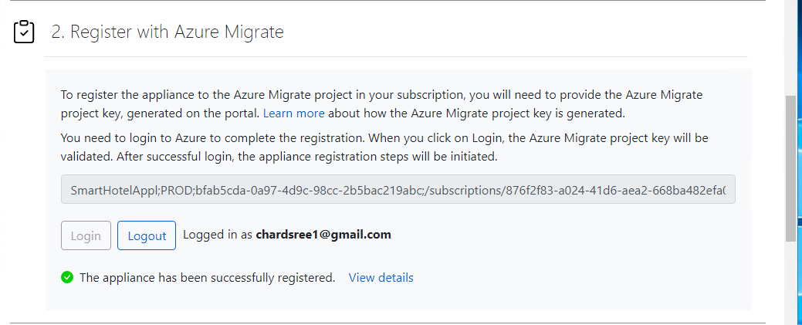

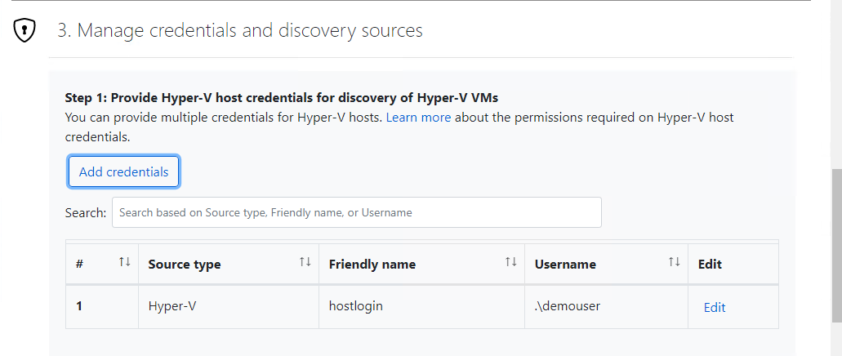

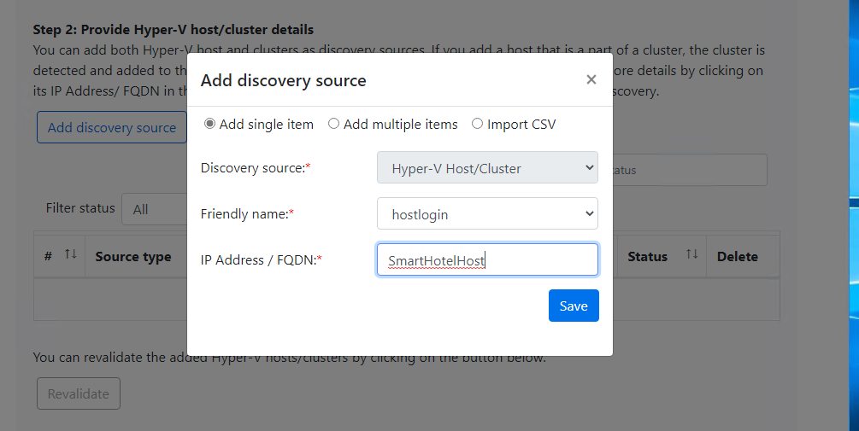

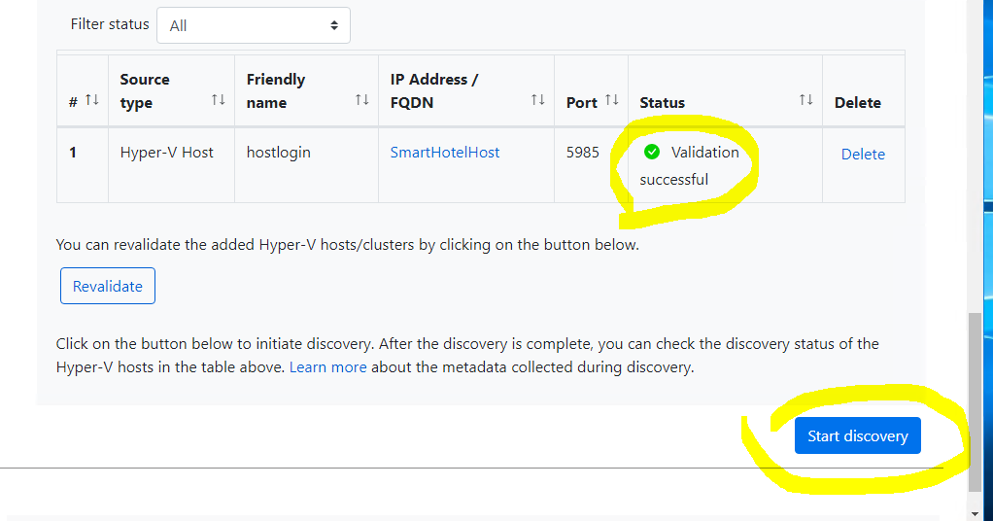

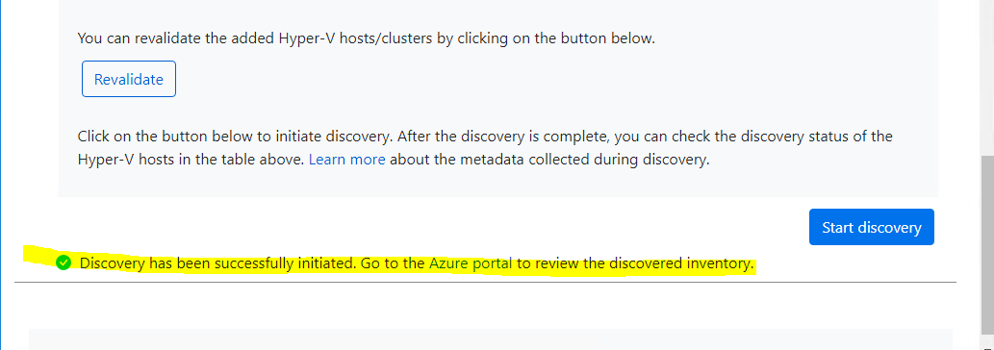

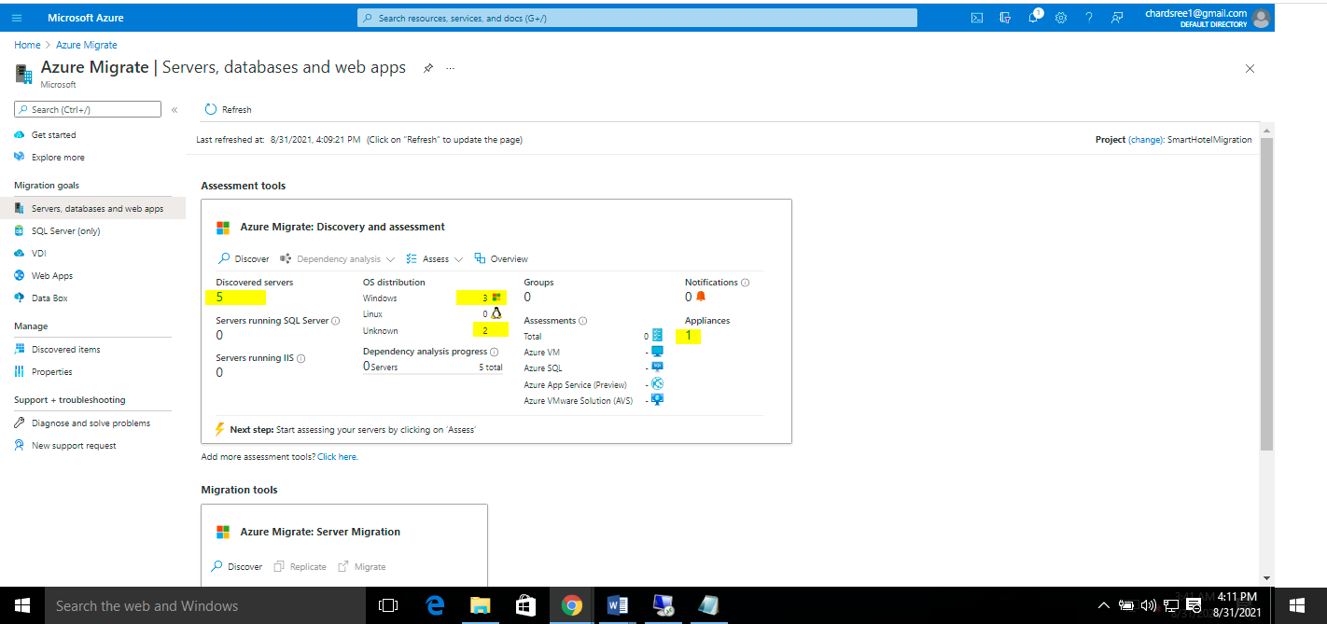

In this task you configured the Azure Migrate appliance in the on-premises Hyper-V environment and started the migration assessment discovery process.

### Task 4: Create a migration assessment

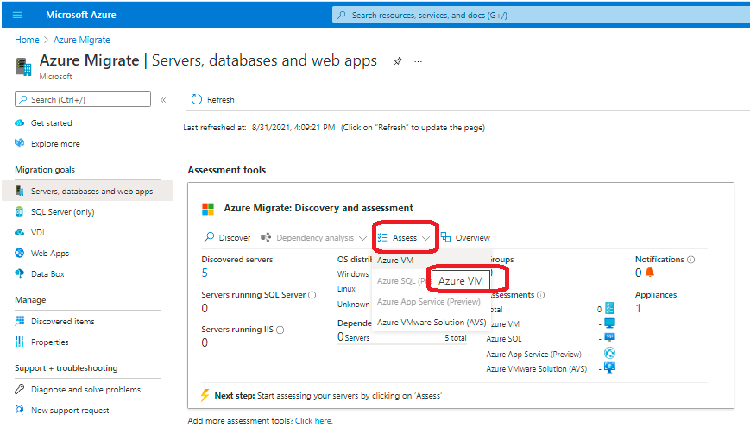

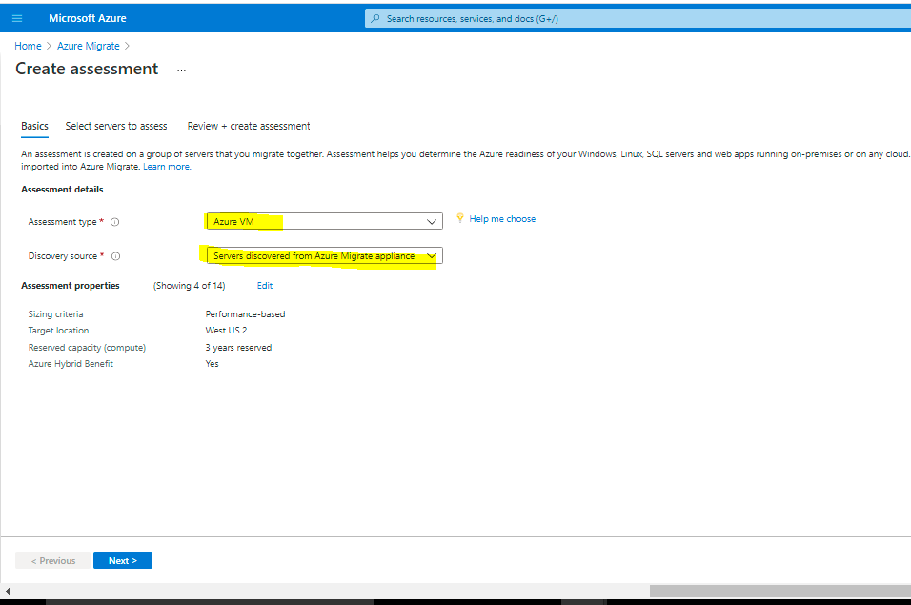

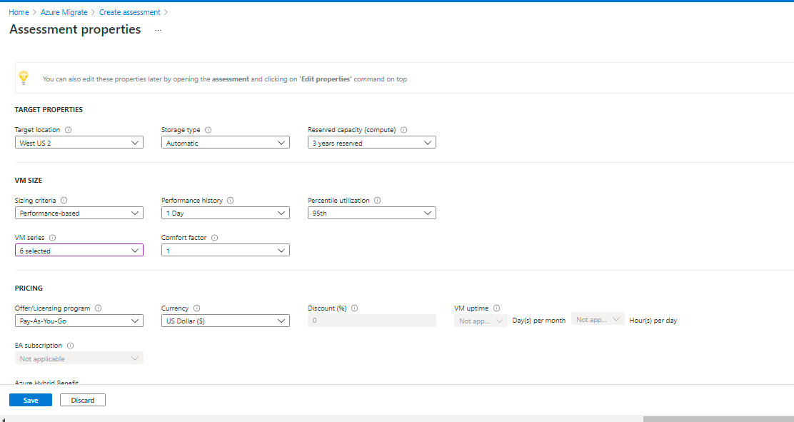

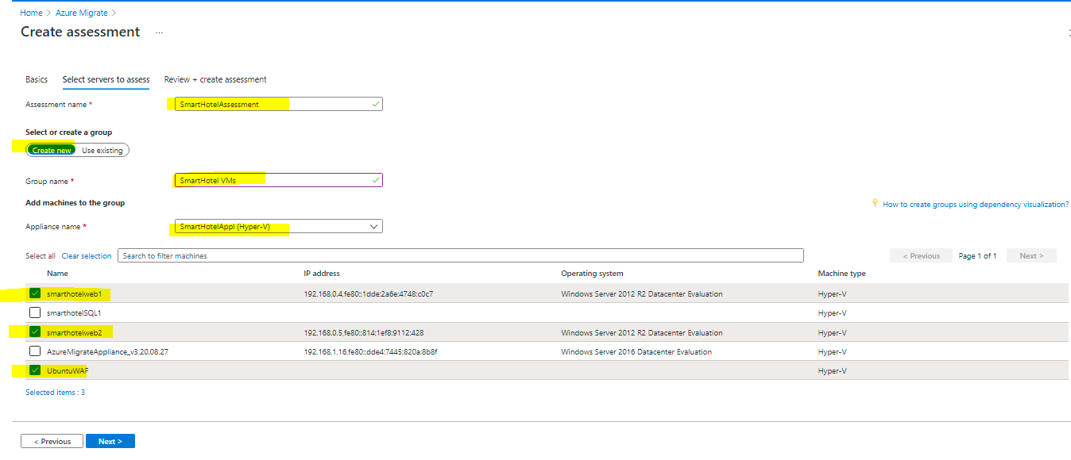

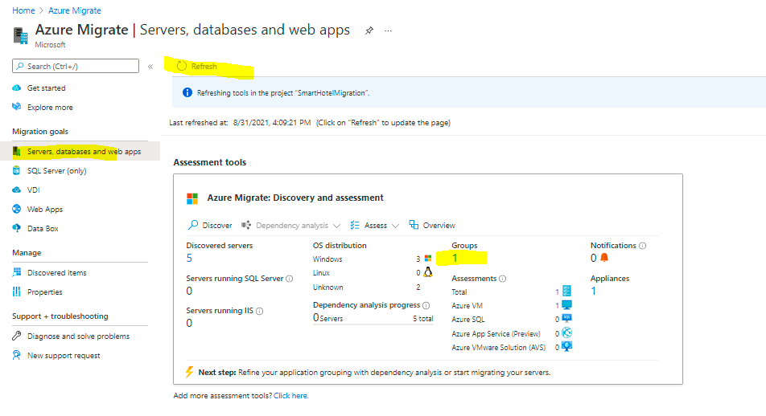

Below step we will select the assessment which we created

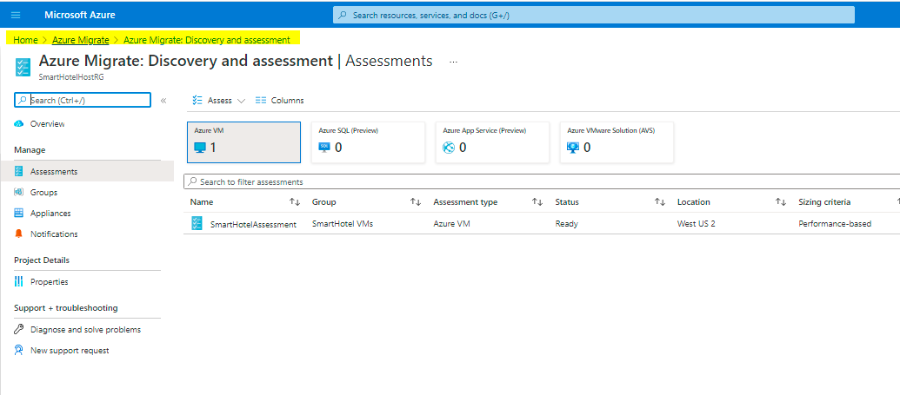

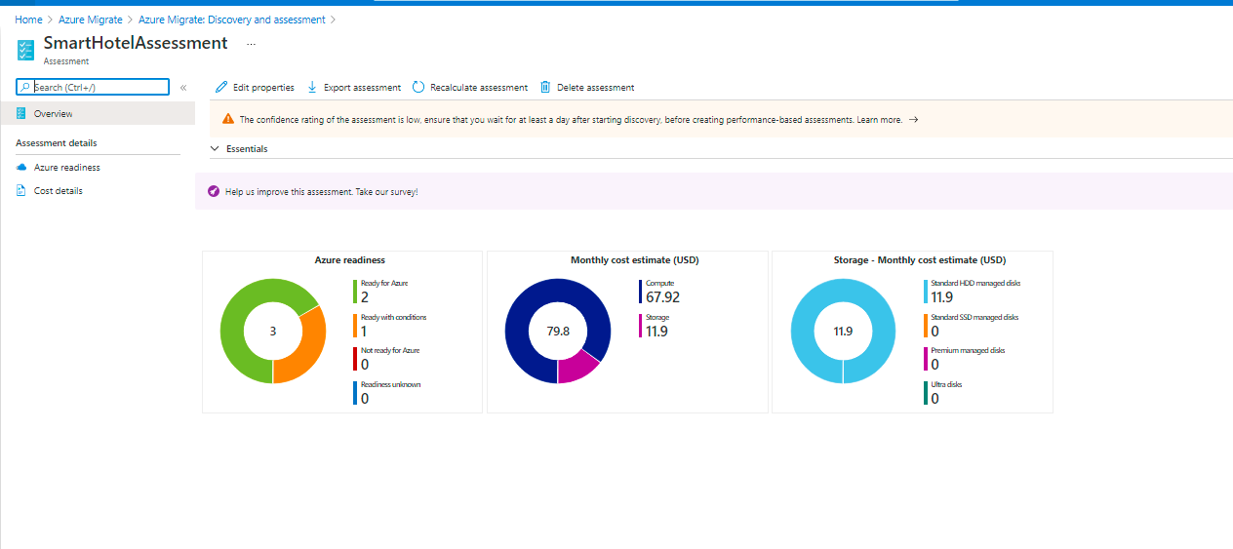

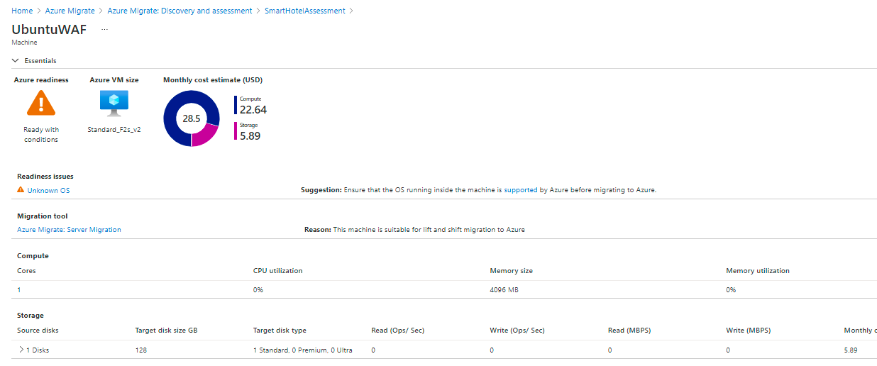

### Task 5: Configure dependency visualization

When migrating a workload to Azure, it is important to understand all workload dependencies. A broken dependency could mean that the application doesn't run properly in Azure, perhaps in hard-to-detect ways. Some dependencies, such as those between application tiers, are obvious. Other dependencies, such as DNS lookups, Kerberos ticket validation or certificate revocation checks, are not.

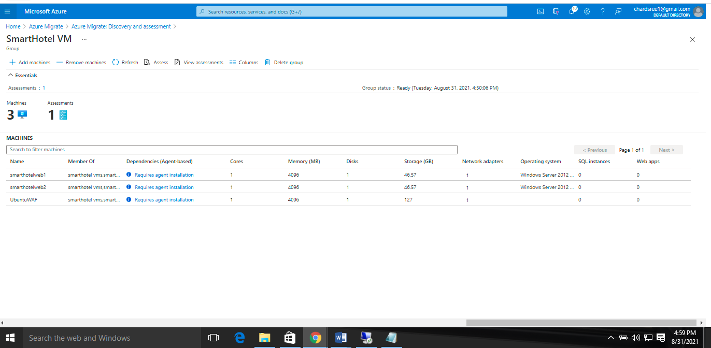

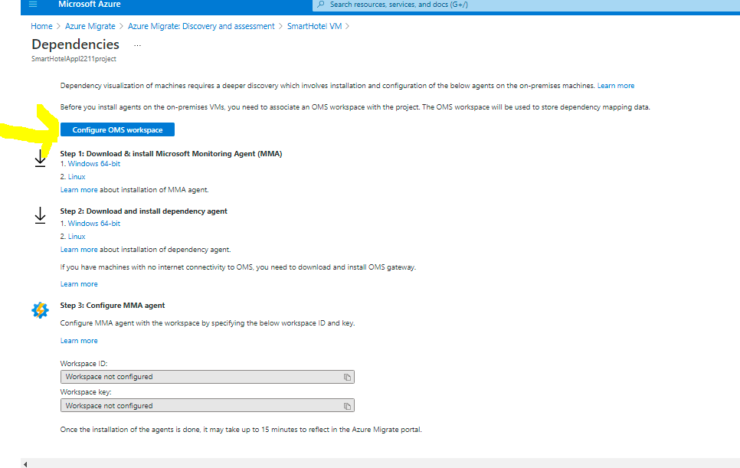

Connect to Smarthotelhost and connect to web1 install

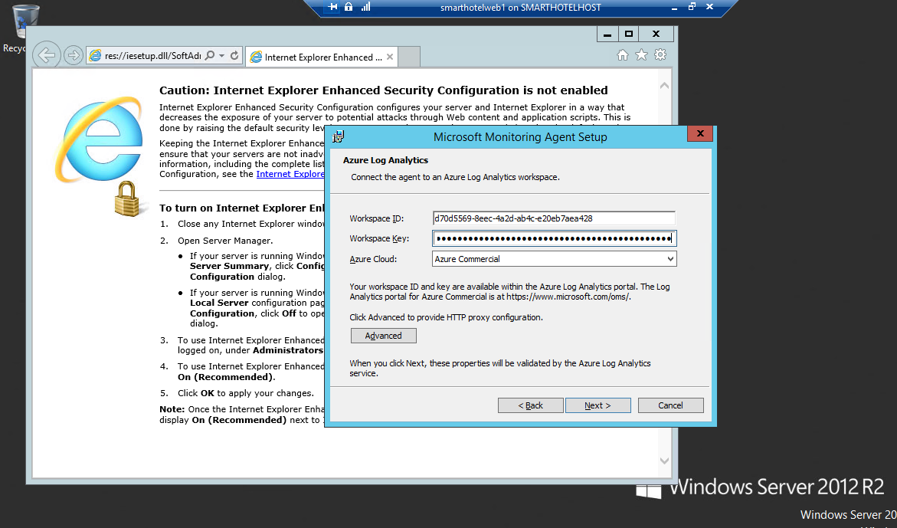

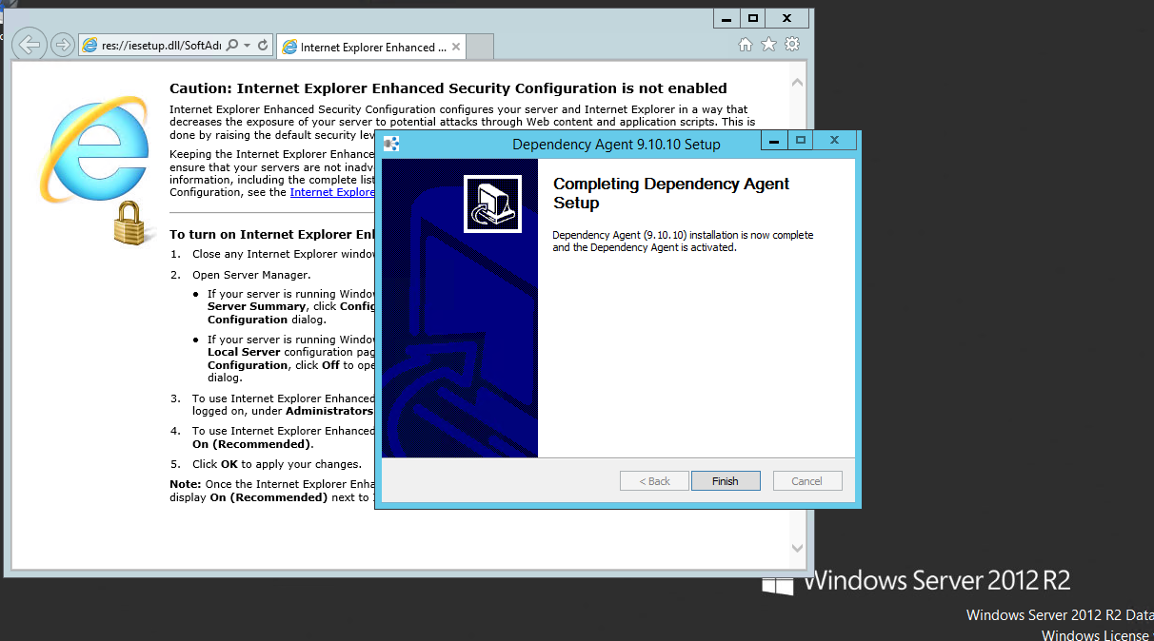

Agent installation Ubuntu VM

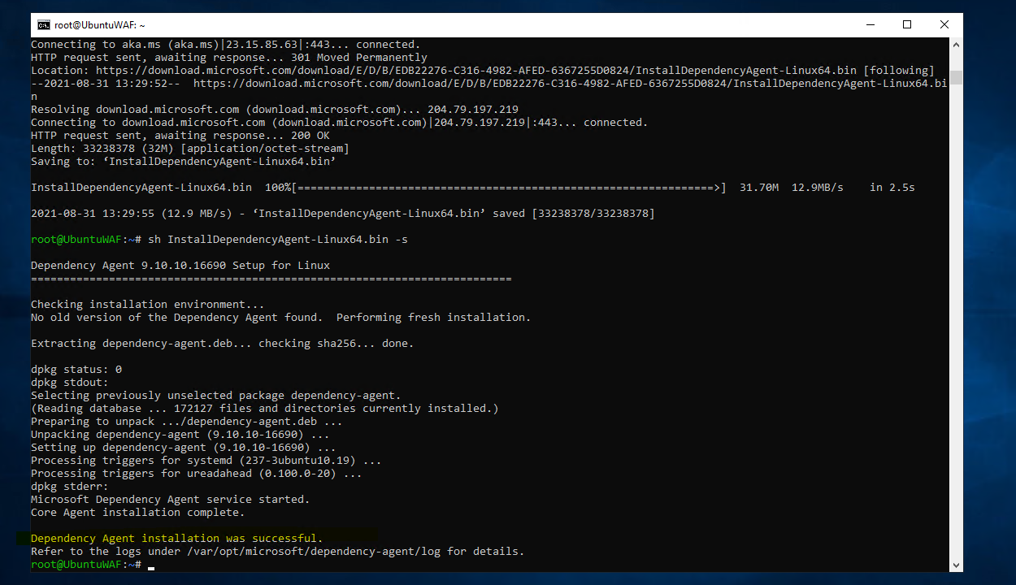

In this task you configured the Azure Migrate dependency visualization feature, by creating a Log Analytics workspace and deploying the Azure Monitoring Agent and Dependency Agent on both Windows and Linux on-premises machines.

### Task 6: Explore dependency visualization

## Exercise 2: Migrate the Application Database

## Task 1: Register the Microsoft.DataMigration resource provider

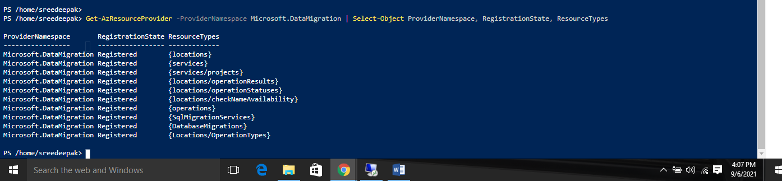

## Task 2: Create an Azure SQL Database

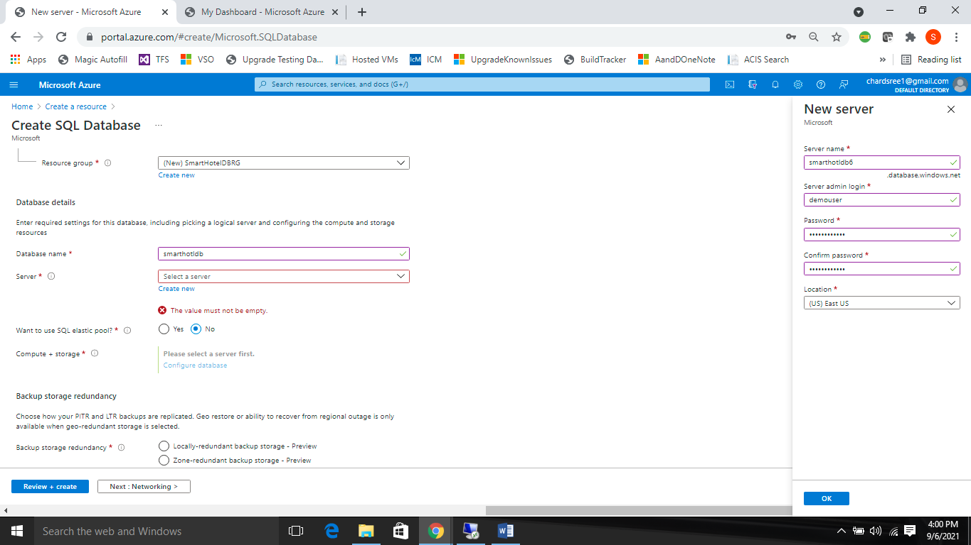

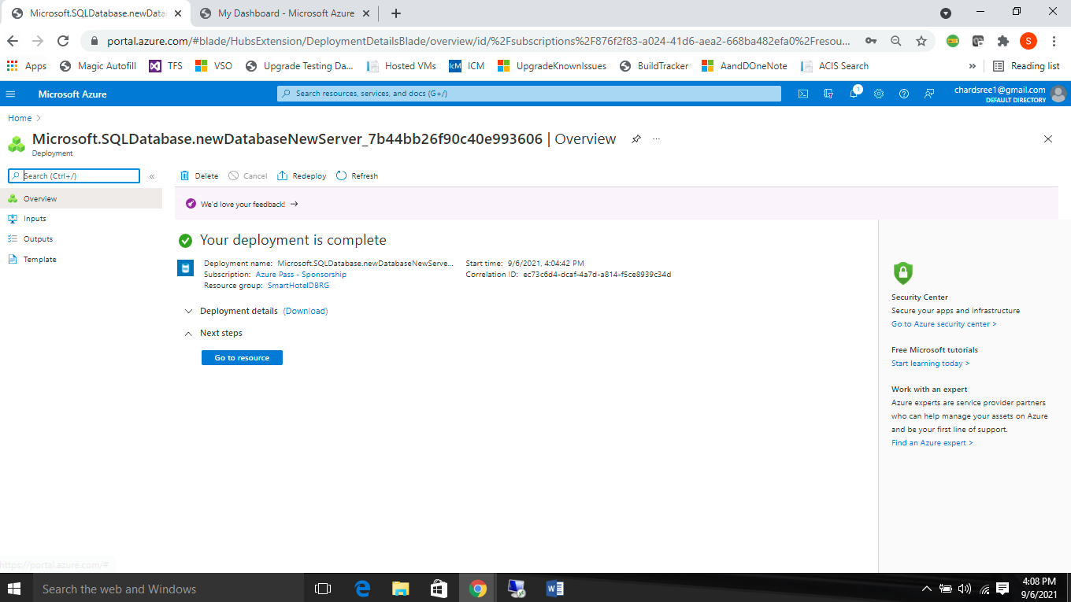

## Task 3: Create the Database Migration Service

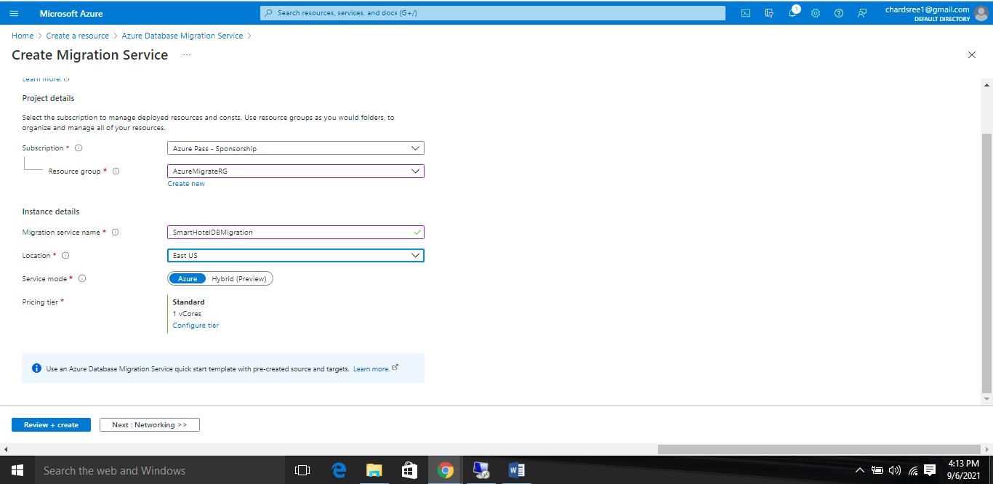

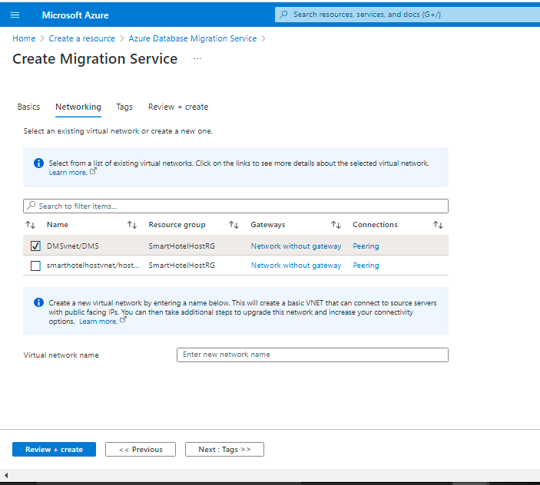

In this task you created a new Azure Database Migration Service resource.

## Task 4: Assess the on-premises database using Data Migration Assistant

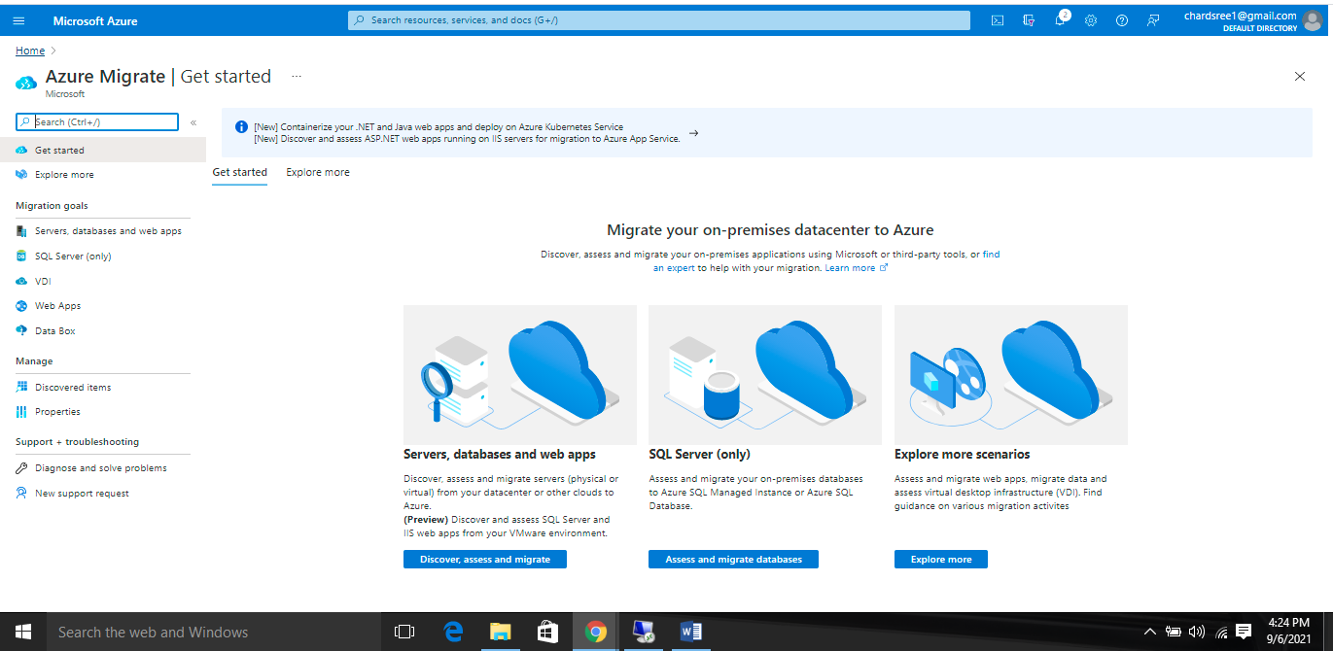

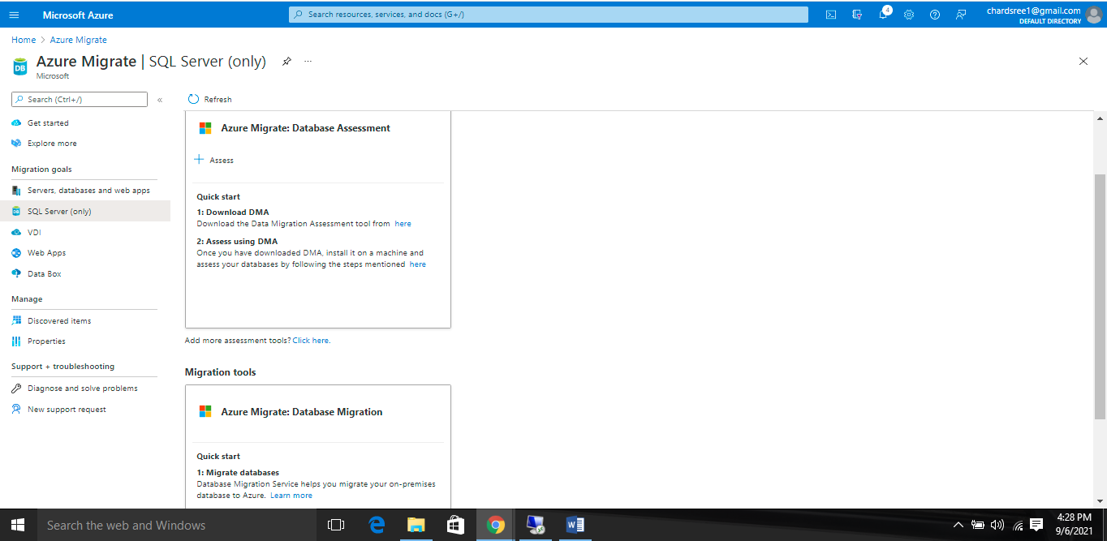

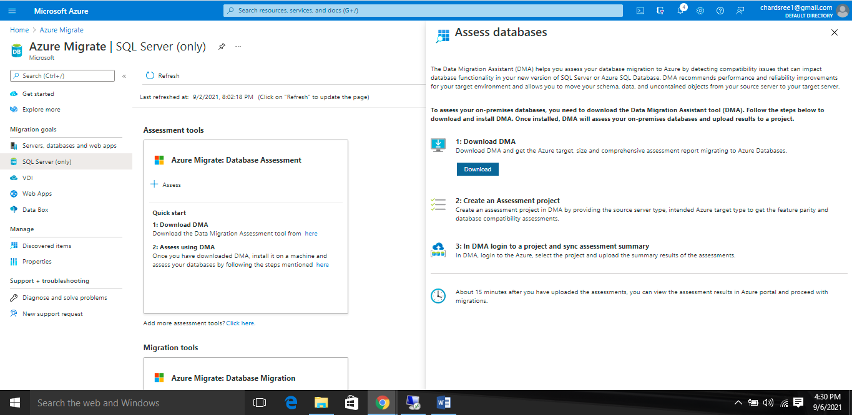

Download and install tool in smarthotelhost

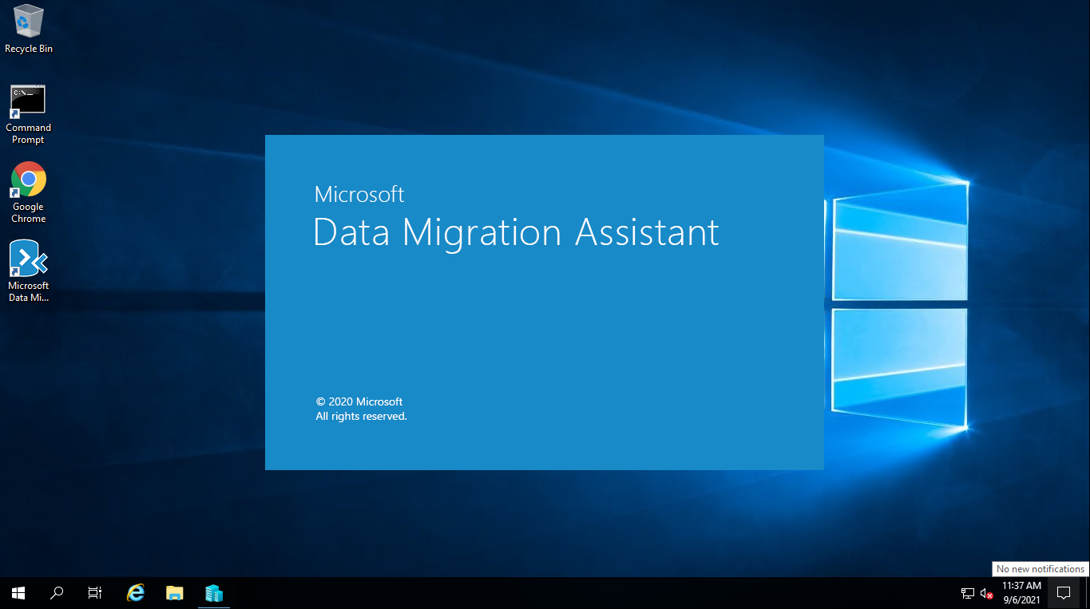

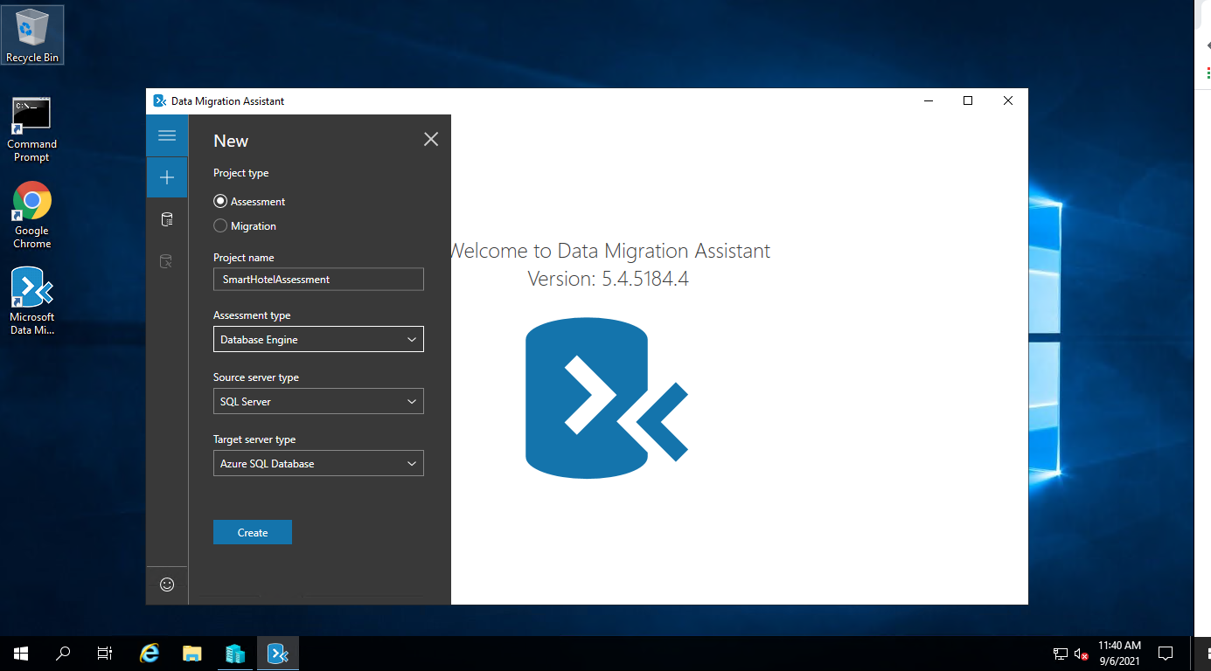

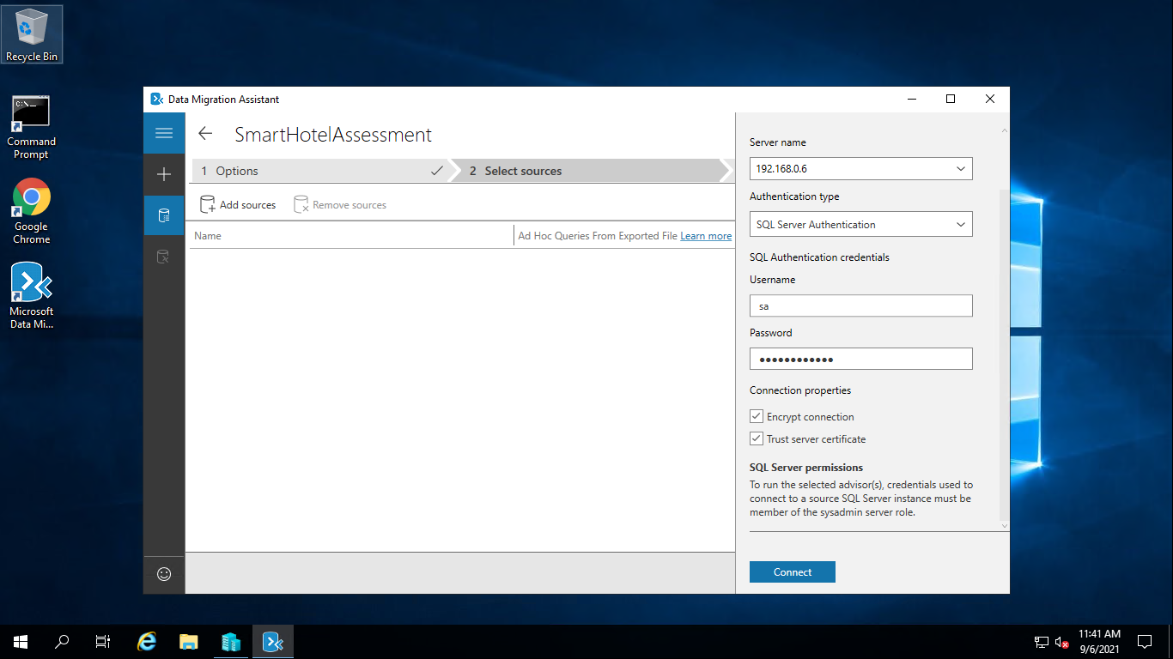

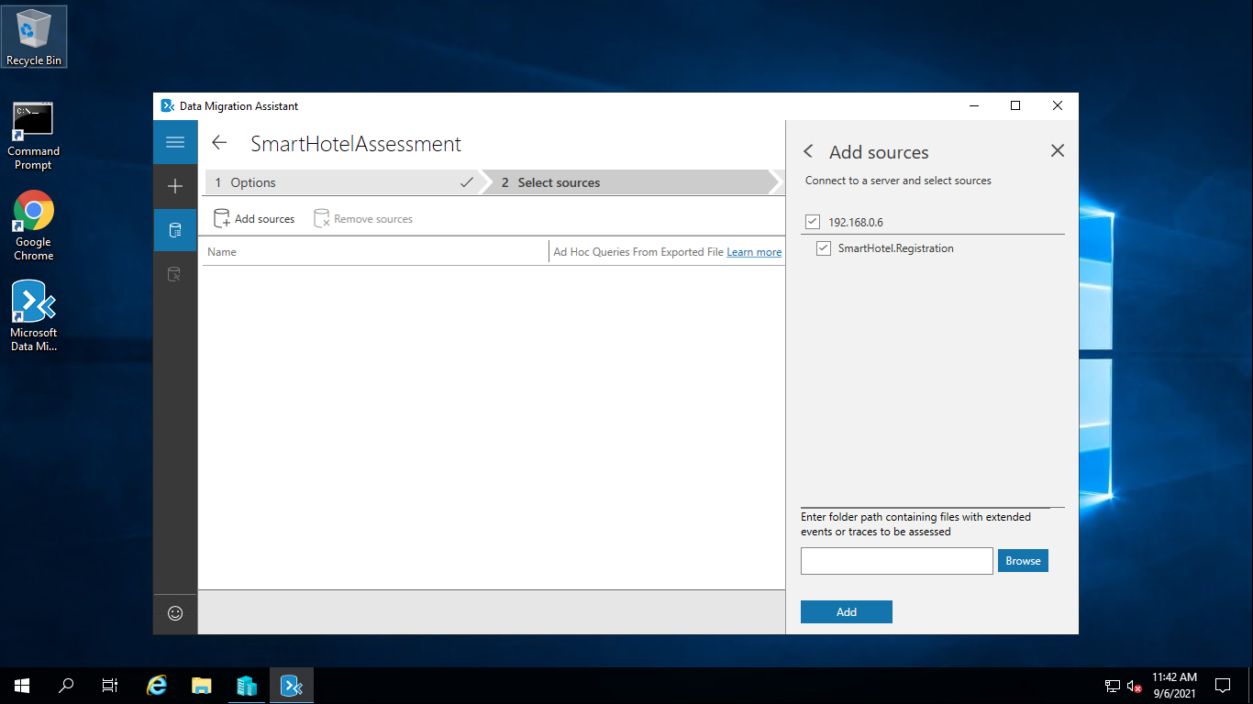

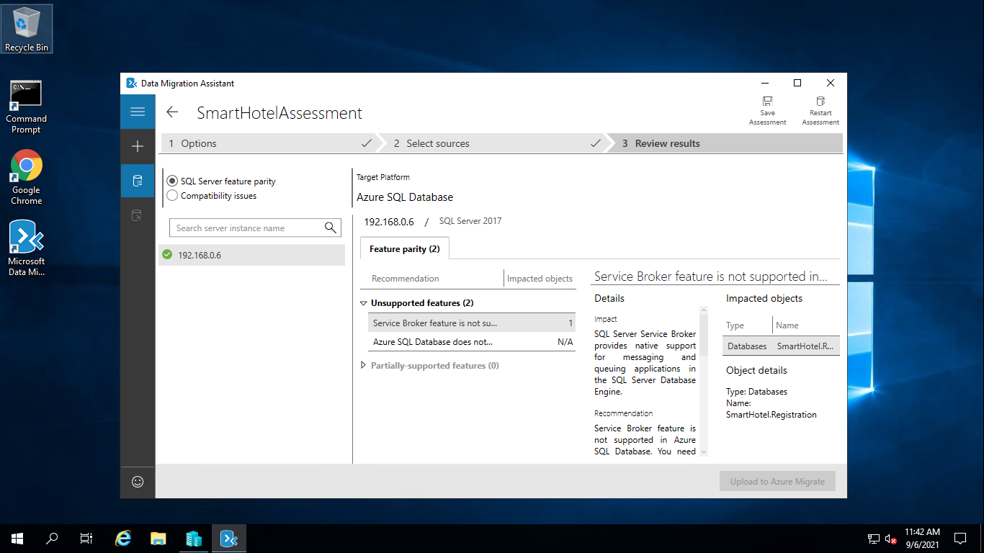

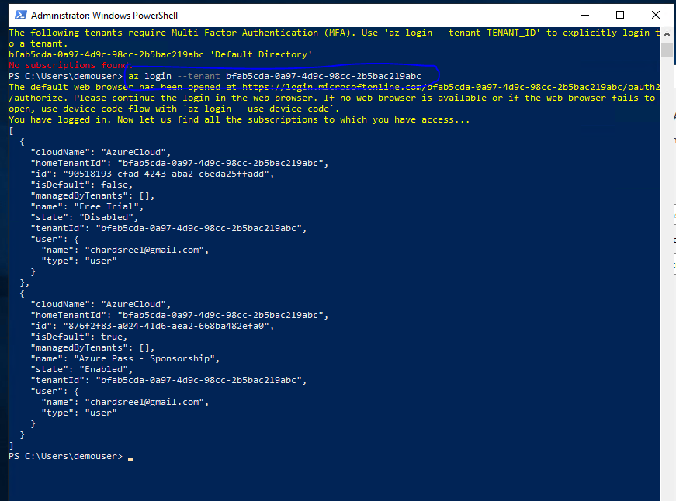

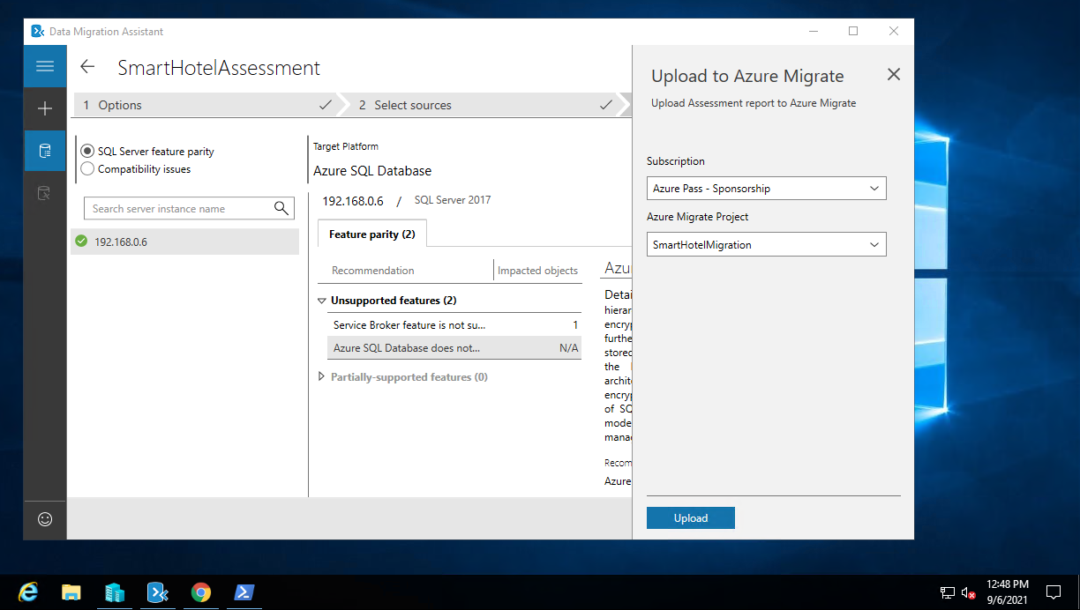

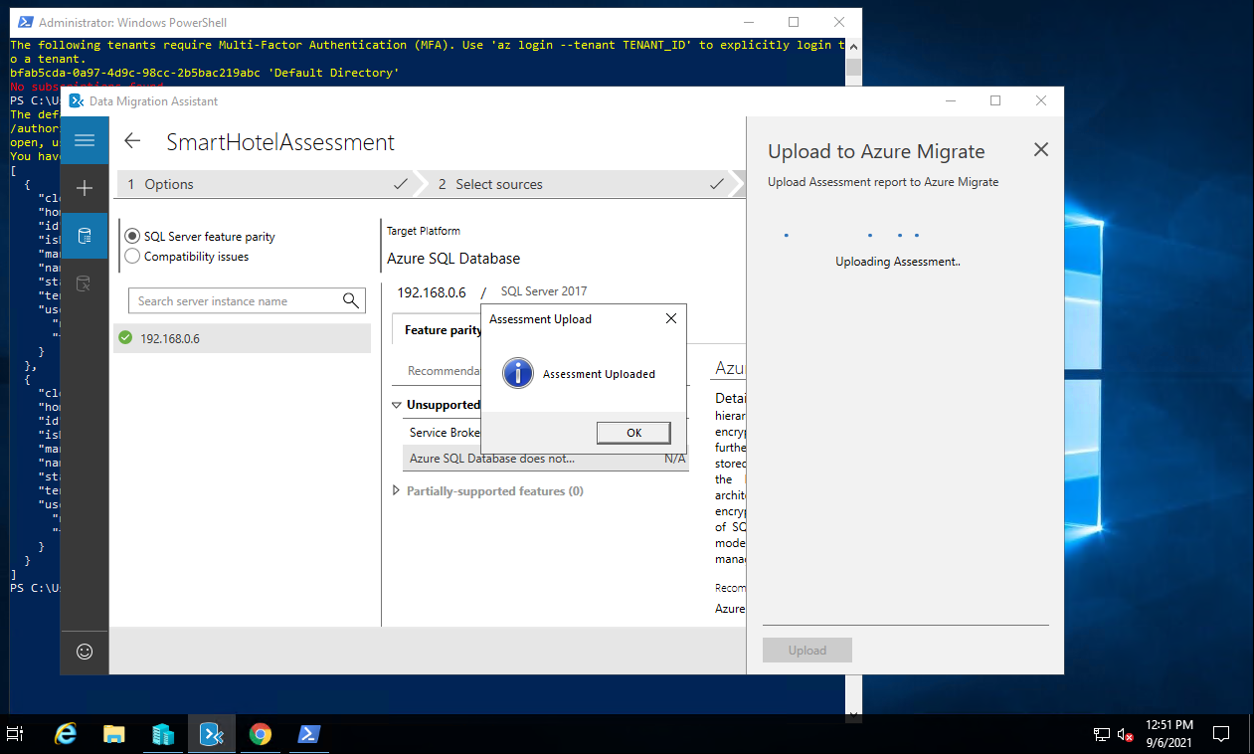

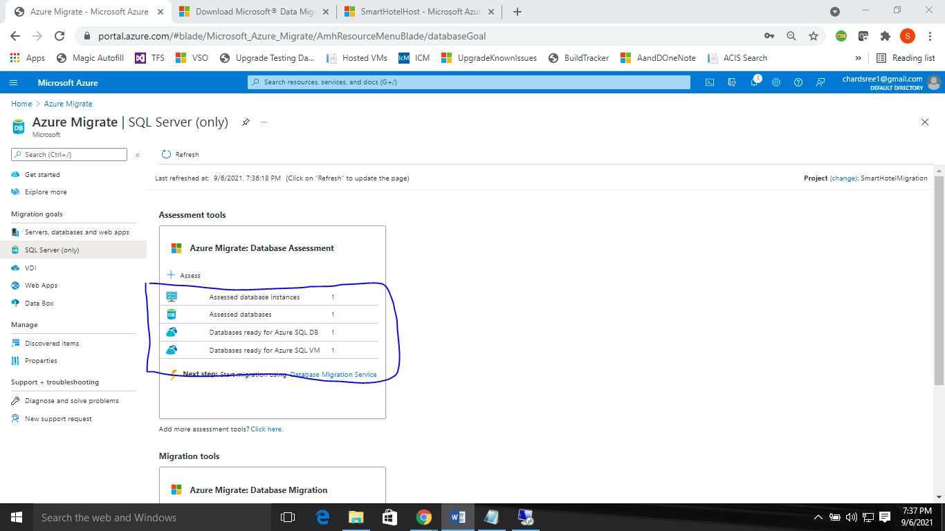

### Task 5: Create a DMS migration project

In this task you will create a Migration Project within the Azure Database Migration Service (DMS). This project contains the connection details for both the source and target databases. In order to connect to the target database, you will also create a private endpoint allowing connectivity from the subnet used by the DMS.

In subsequent tasks, you will use this project to migrate both the database schema and the data itself from the on-premises SQL Server database to the Azure SQL Database.

We'll start by creating the private endpoint that allows the DMS to access the database server.

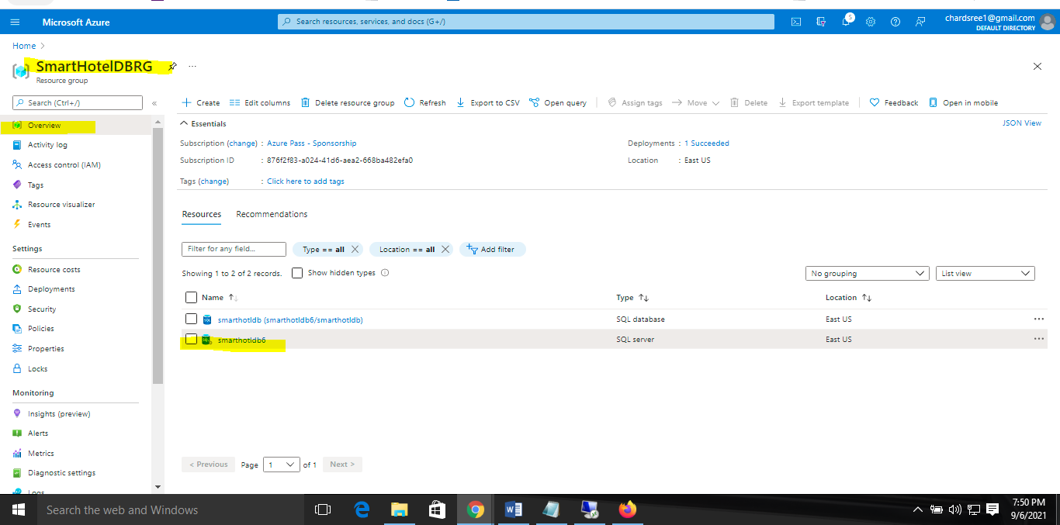

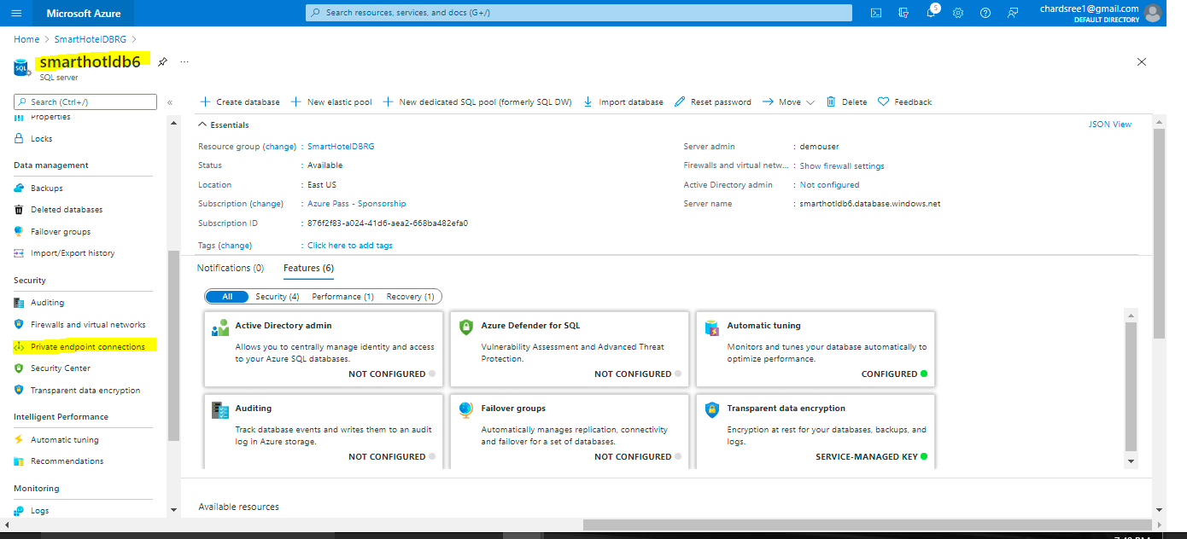

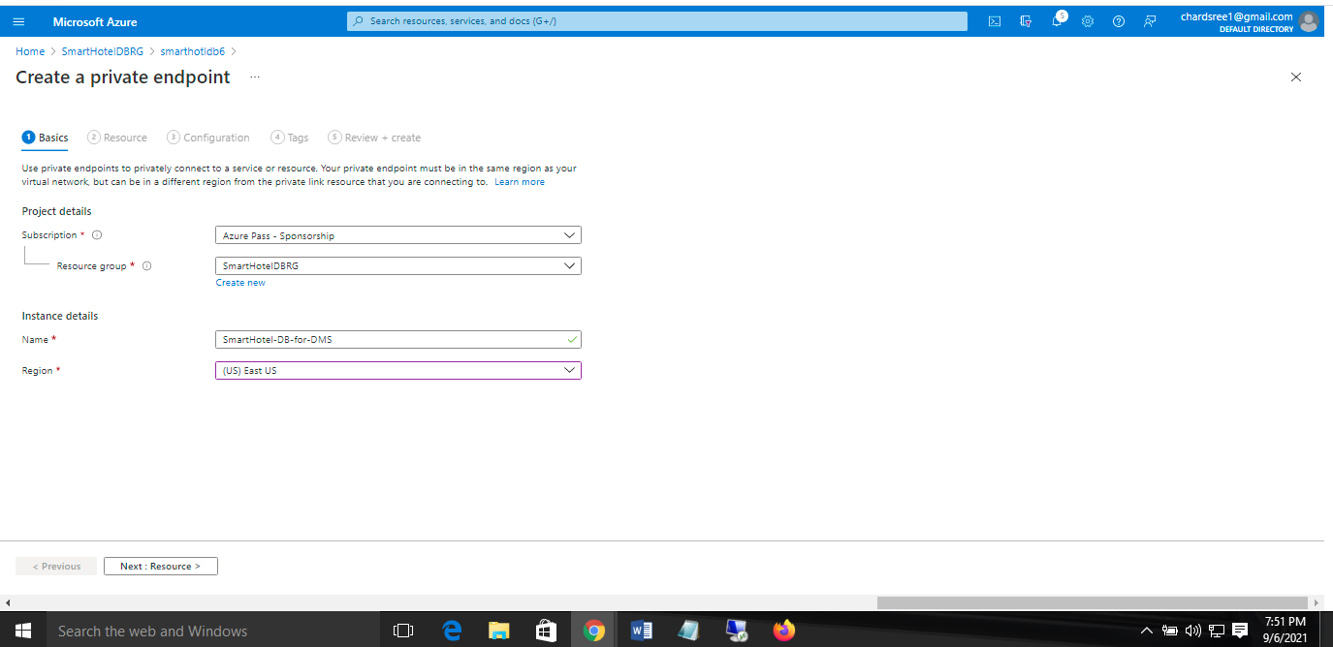

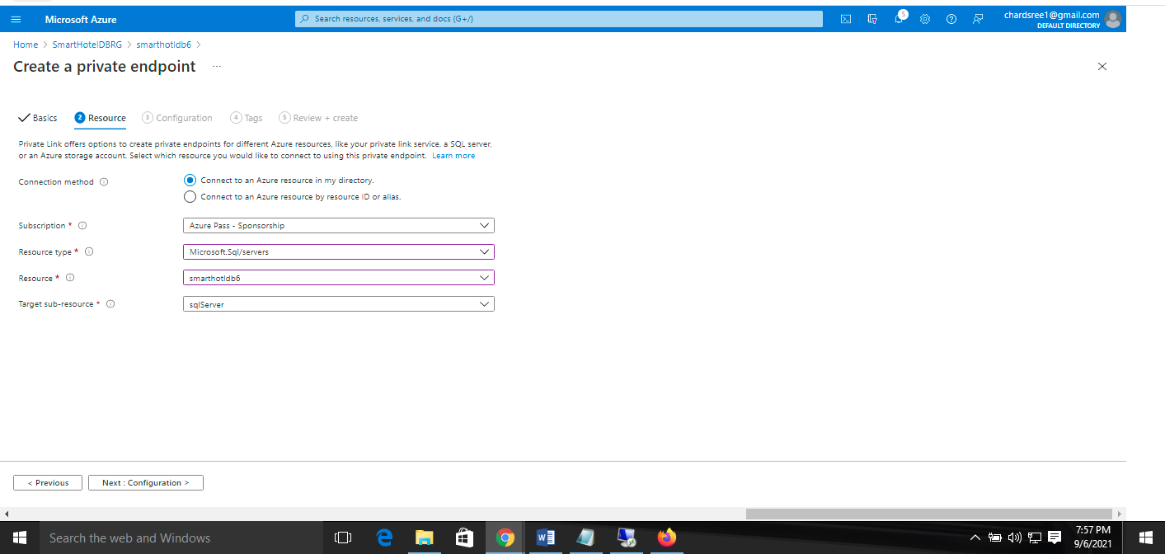

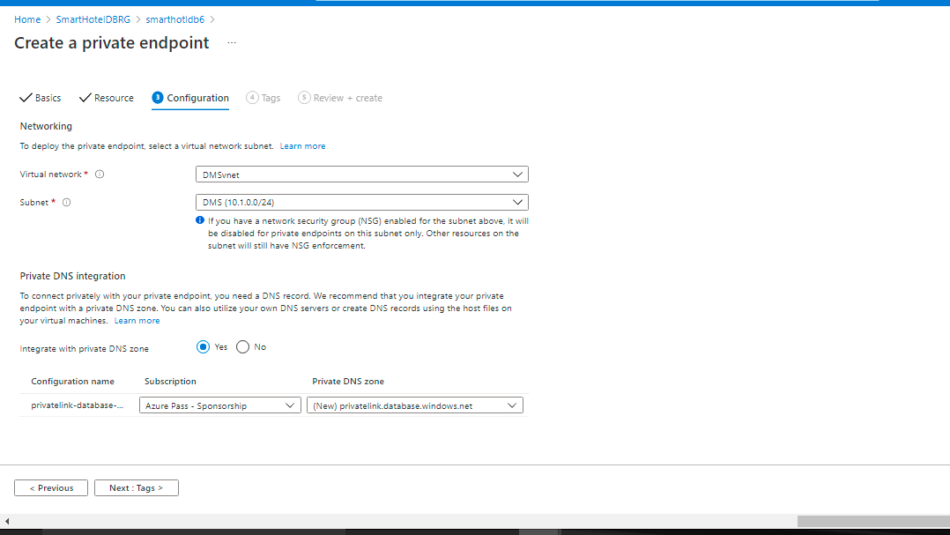

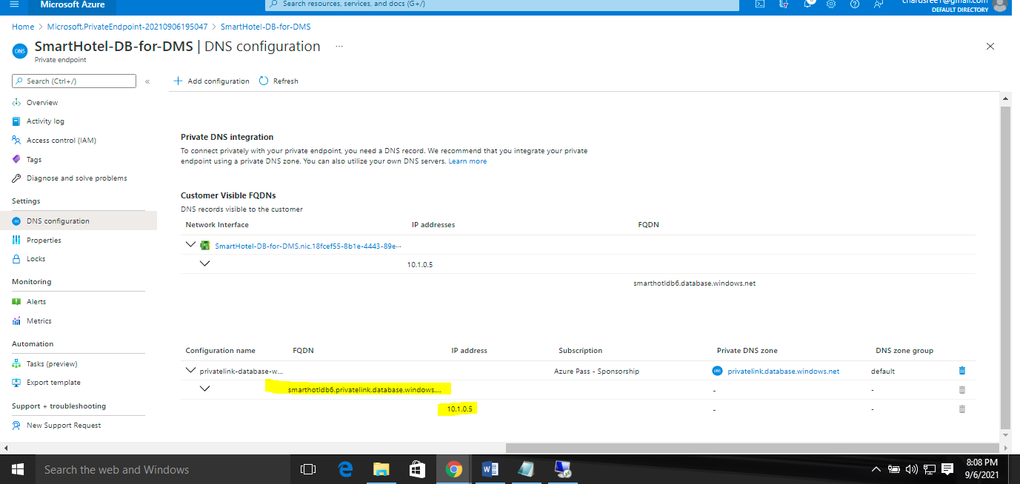

Login to database server and firewall and virtual networks

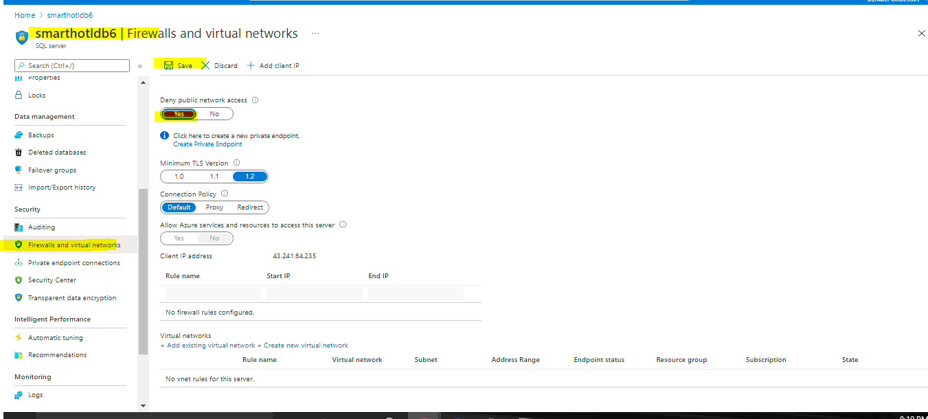

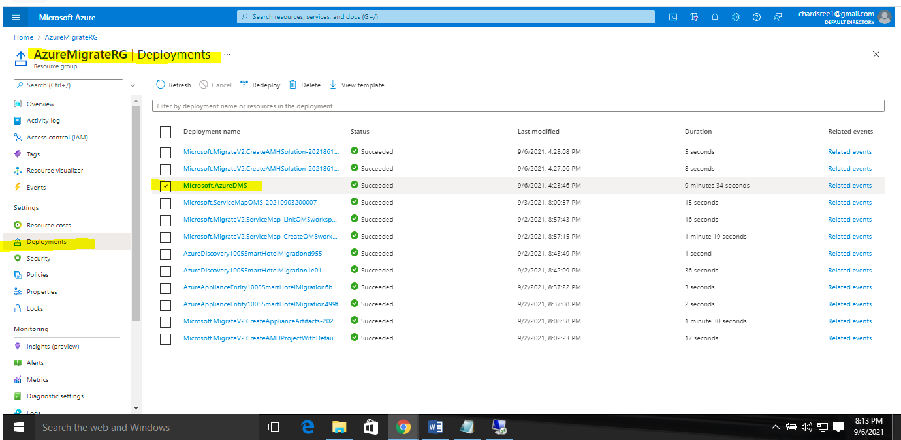

Navigate to the Database Migration Service resource blade in the **AzureMigrateRG** resource group and select **+ New Migration Project**.

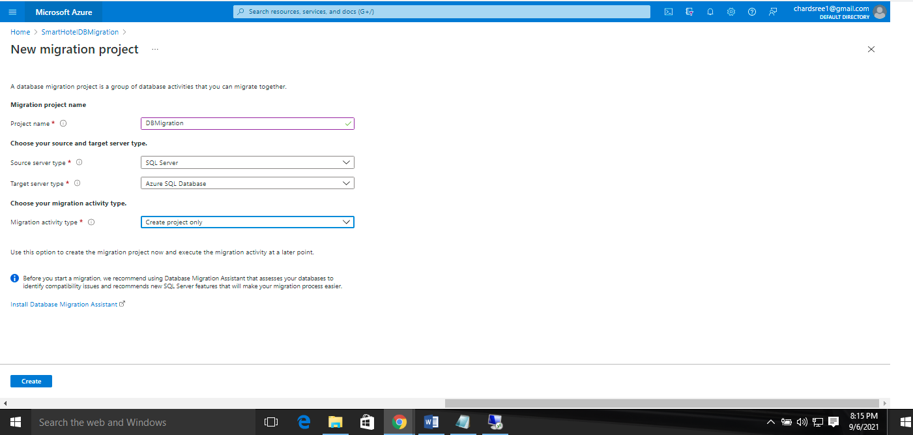

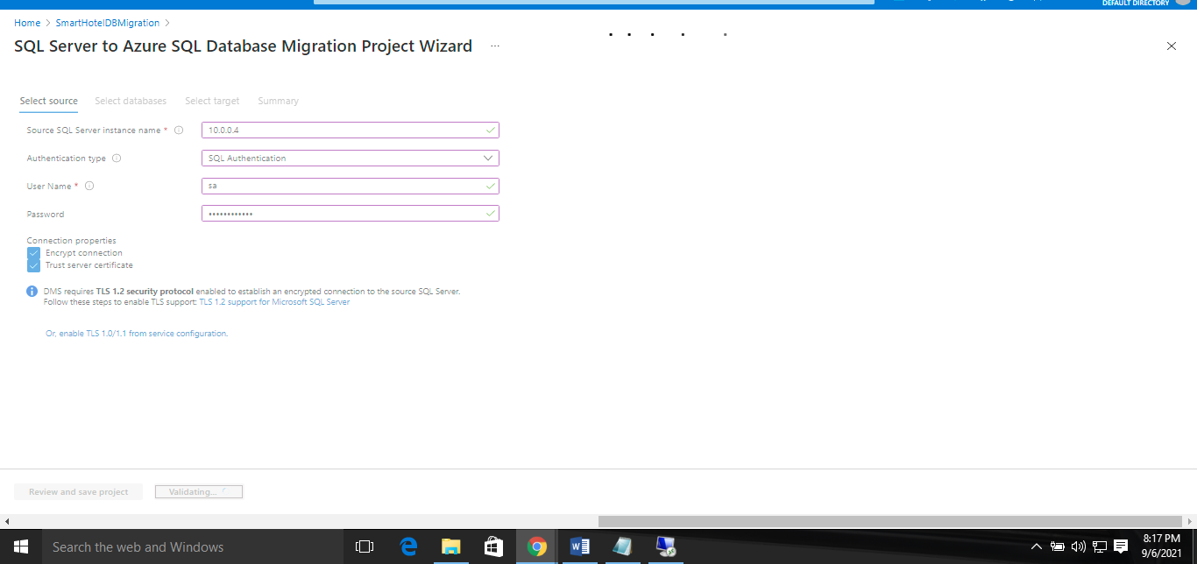

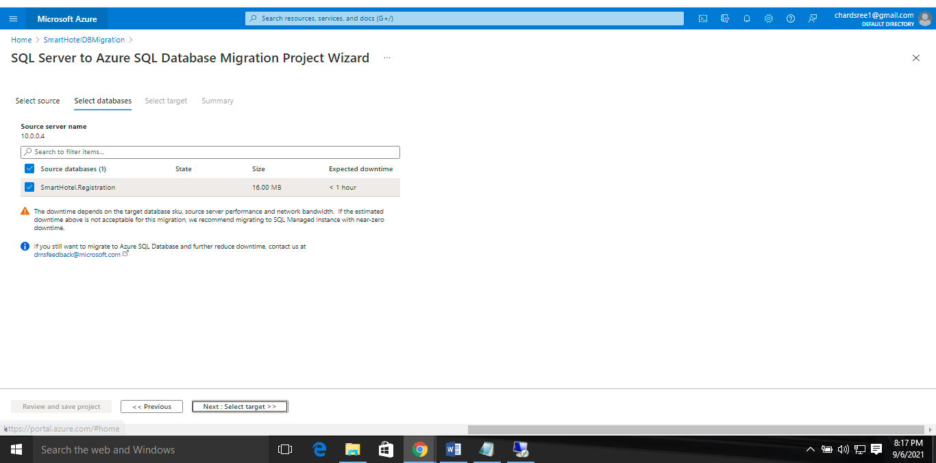

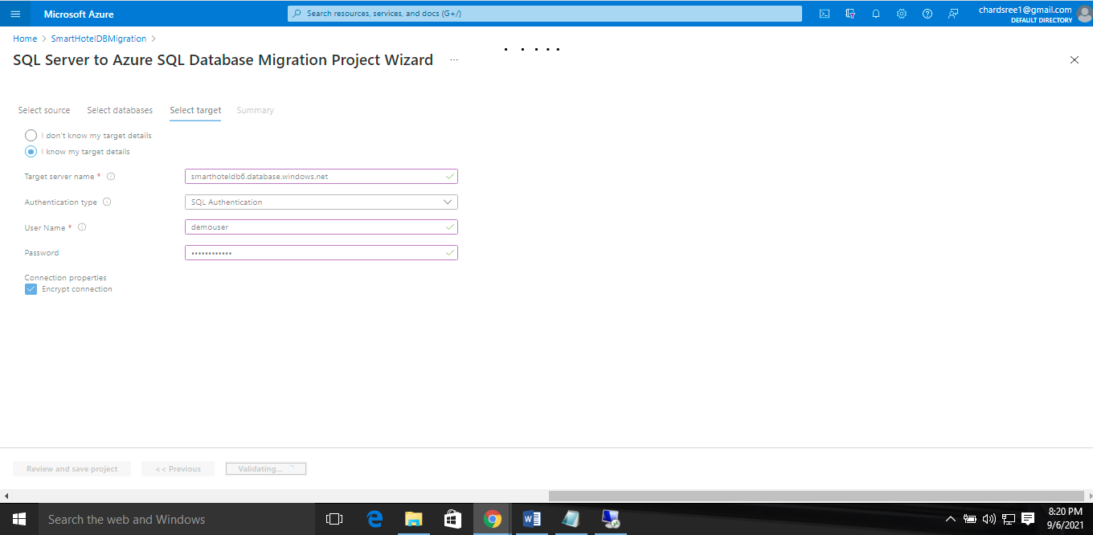

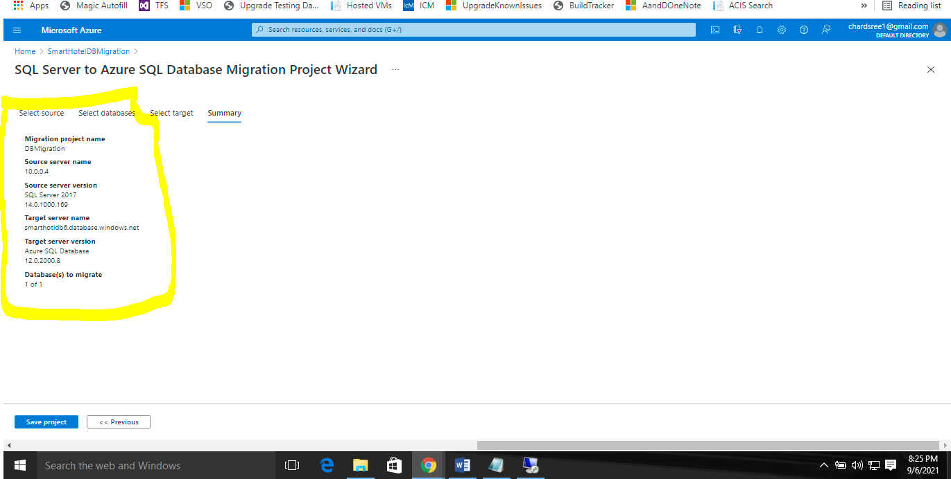

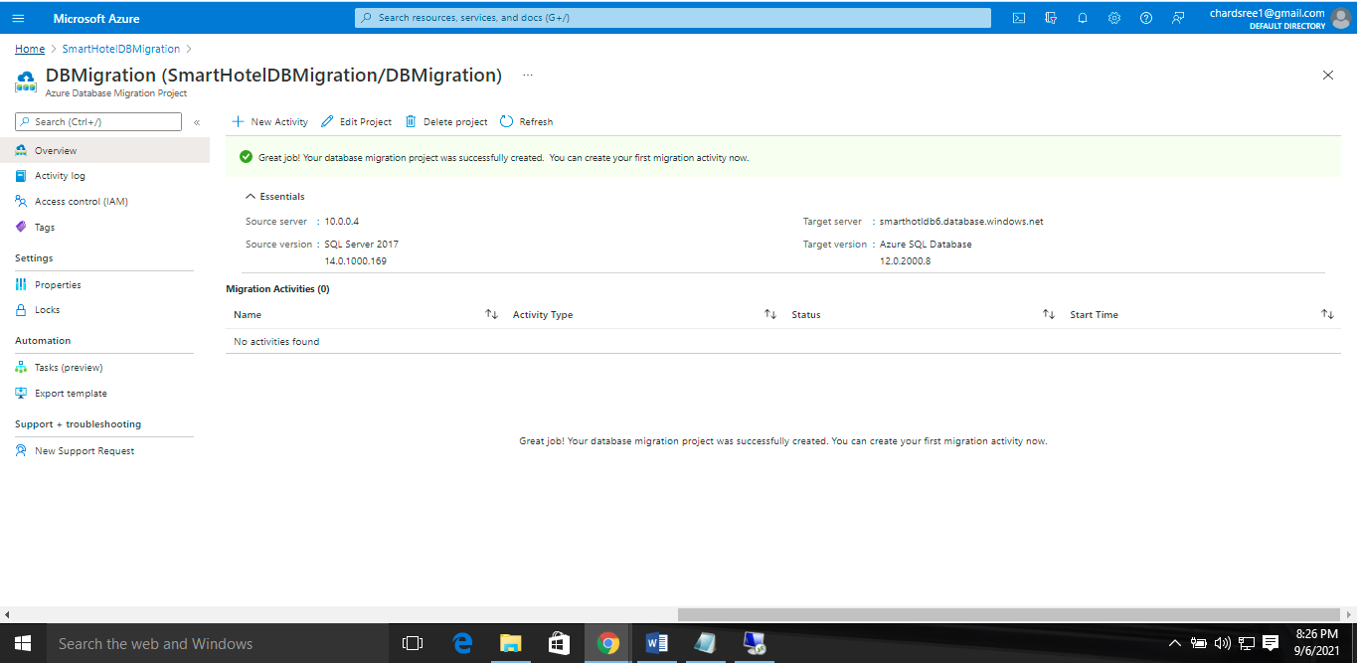

### Task 6: Migrate the database schema

In this task you will use the Azure Database Migration Service to migrate the database schema to Azure SQL Database. This step is a prerequisite to migrating the data itself.

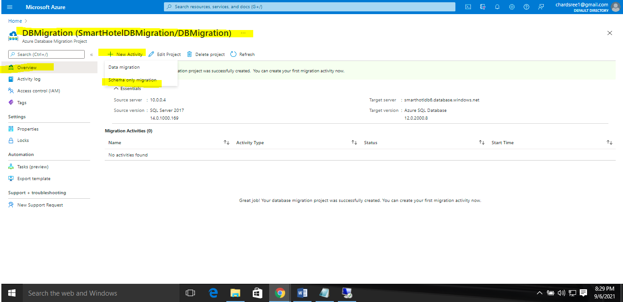

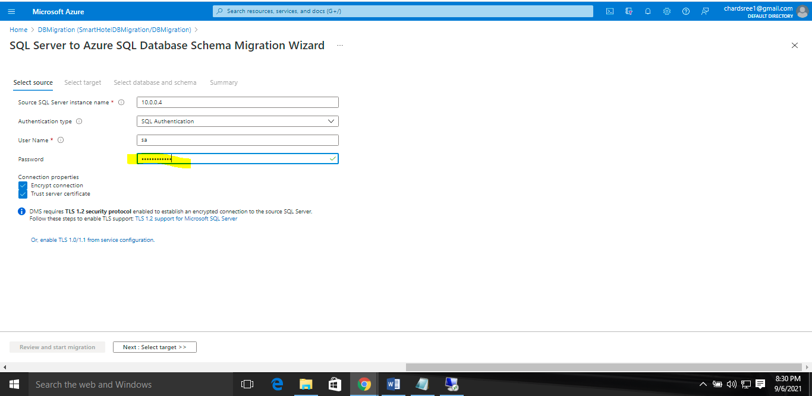

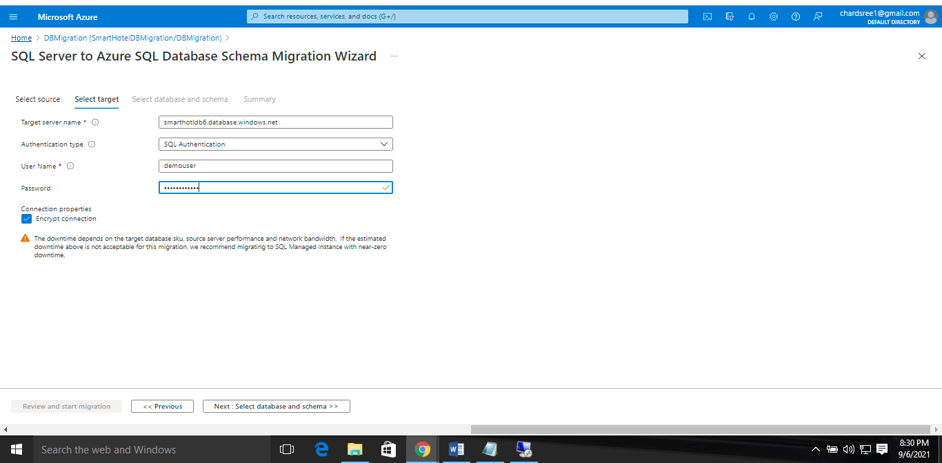

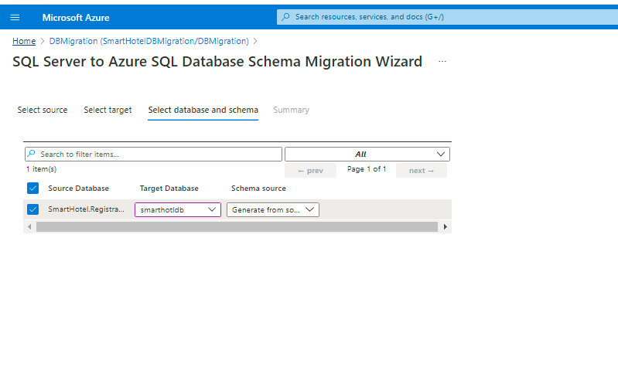

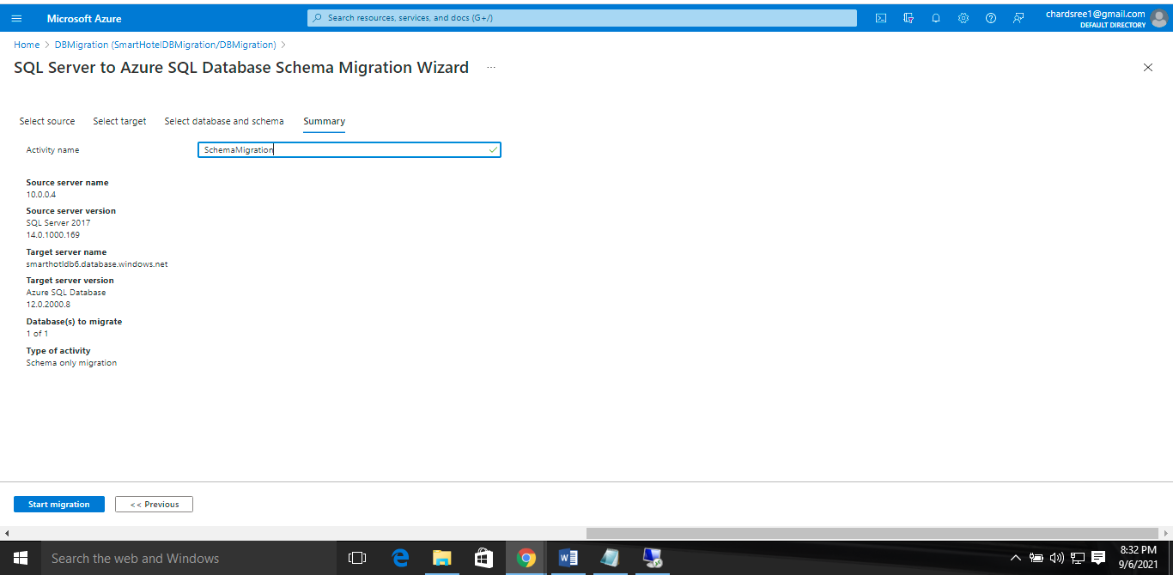

The schema migration will begin. Select the **Refresh** button and watch the migration progress, until it shows as **Completed**.

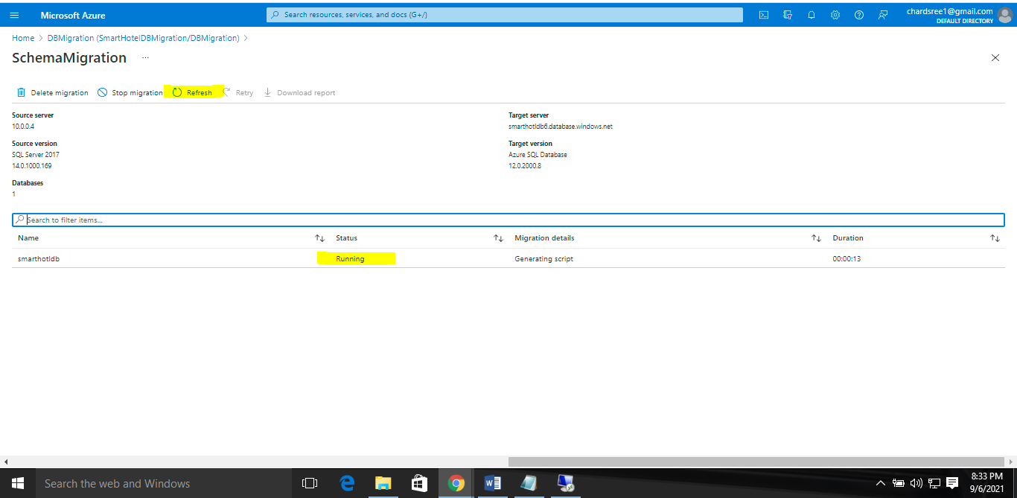

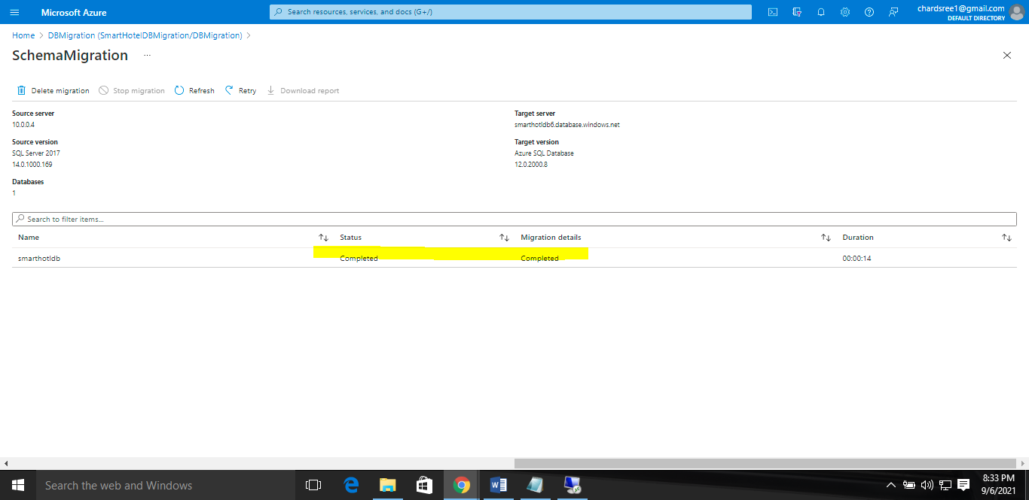

### Task 7: Migrate the on-premises data

### 

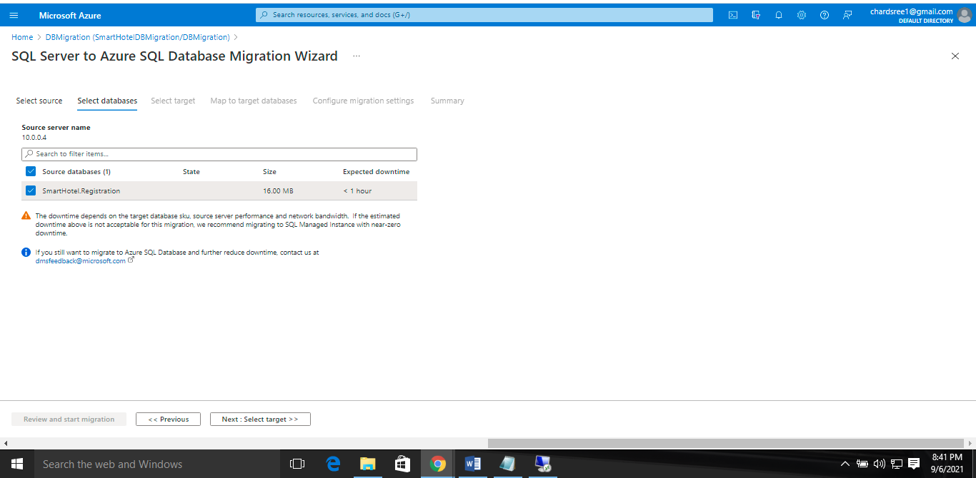

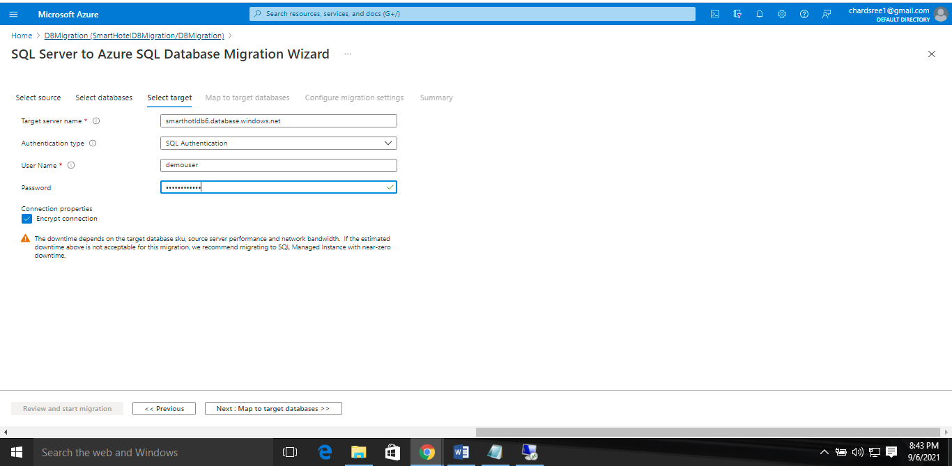

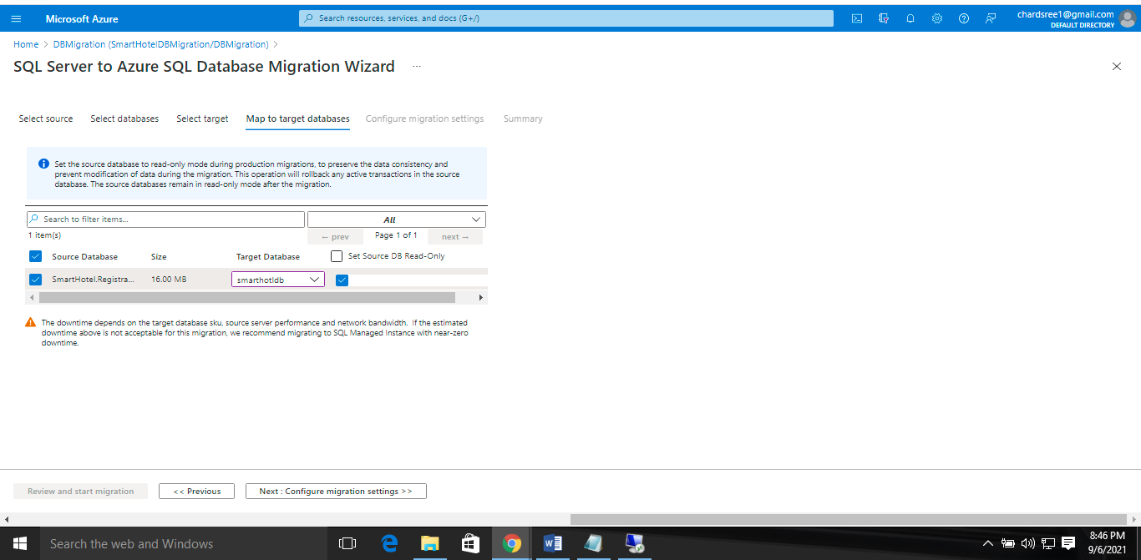

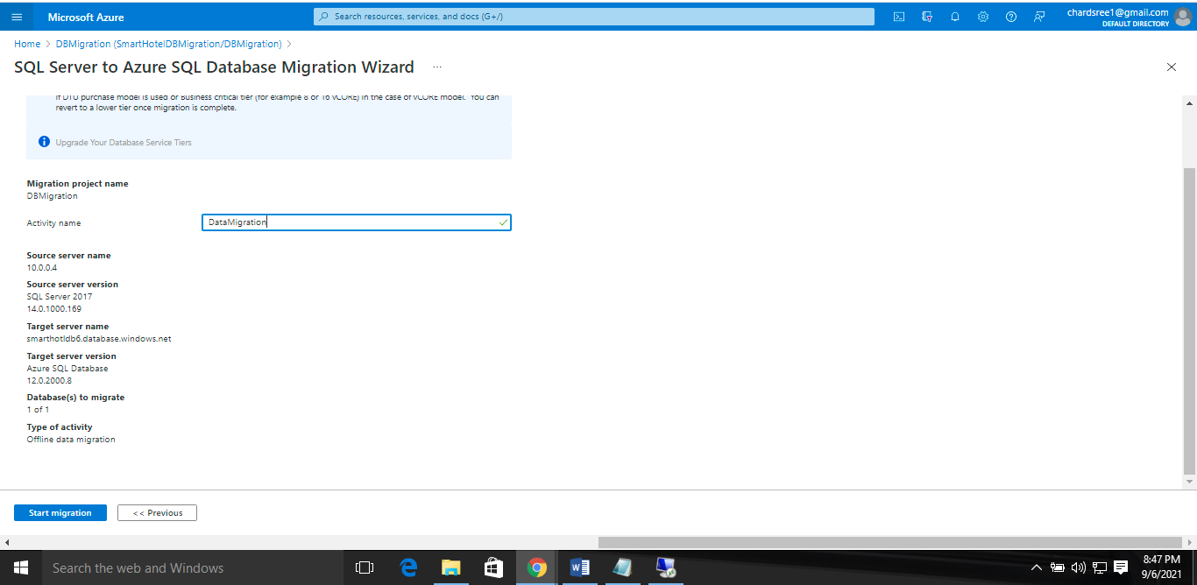

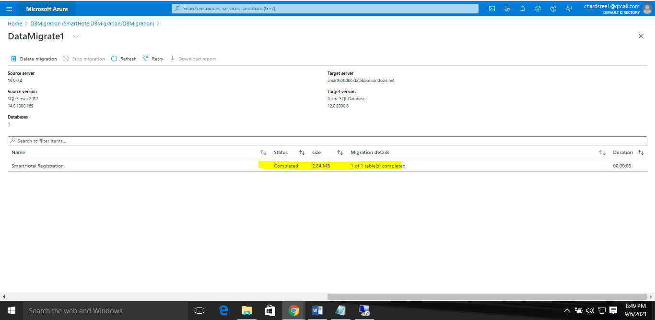

In this exercise you migrated the application database from on-premises to Azure SQL Database. The Microsoft Data Migration Assistant was used for migration assessment, and the Azure Database Migration Service was used for schema migration and data migration.

Remove the private endpoint connection

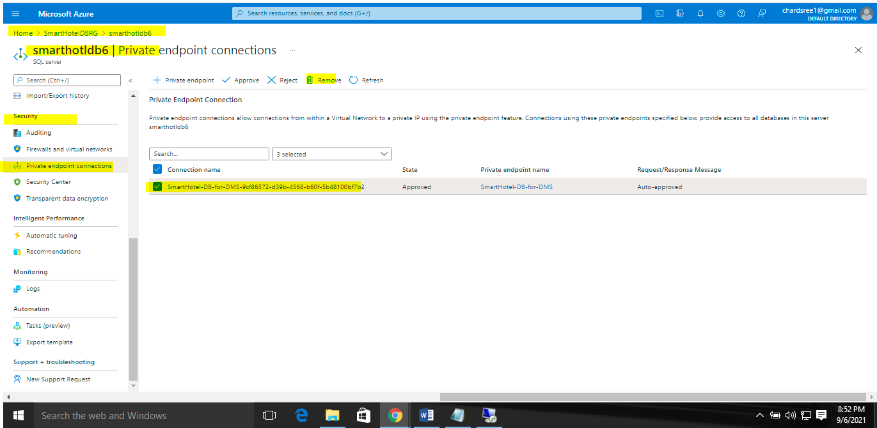

## **Migrate the application and web tiers using Azure Migrate: Server Migration**

In this exercise you will migrate the web tier and application tiers of the application from on-premises to Azure using Azure Migrate: Server Migration.

Having migrated the virtual machines, you will reconfigure the application tier to use the application database hosted in Azure SQL. This will enable you to verify that the migration application is working end-to-end.

### Task 1: Create a Storage Account

In this task you will create a new Azure Storage Account that will be used by Azure Migrate: Server Migration for storage of your virtual machine data during migration

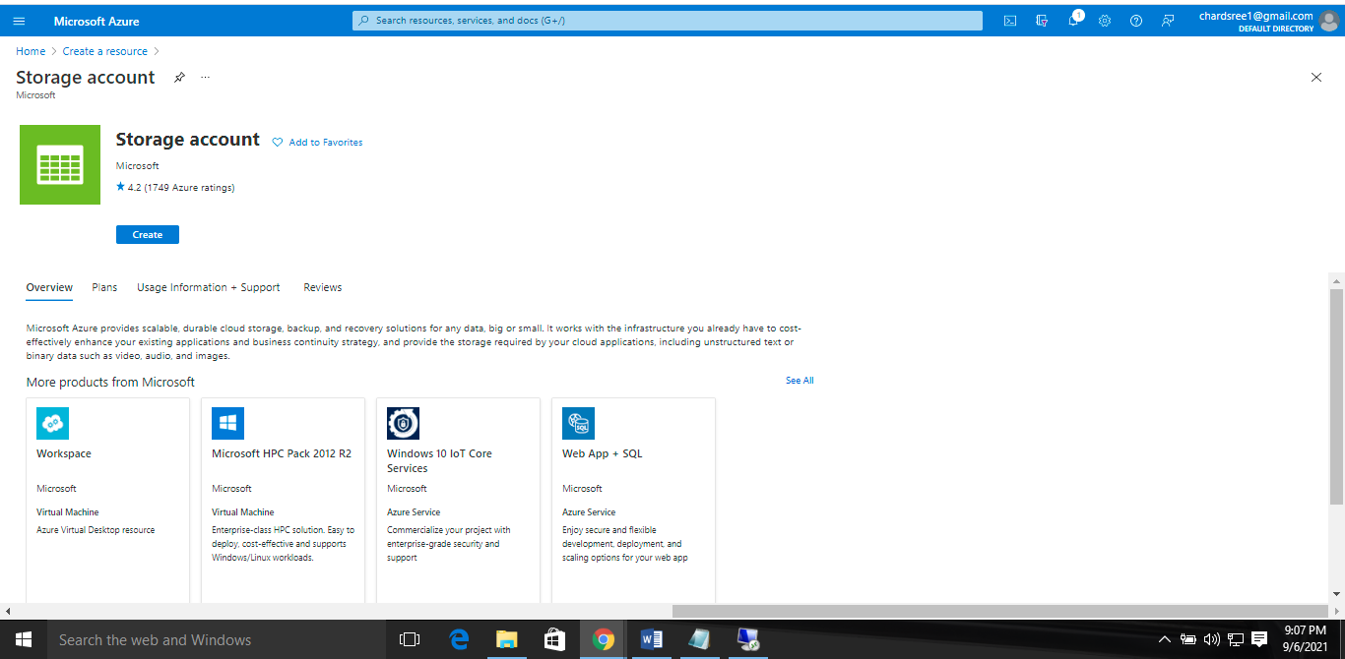

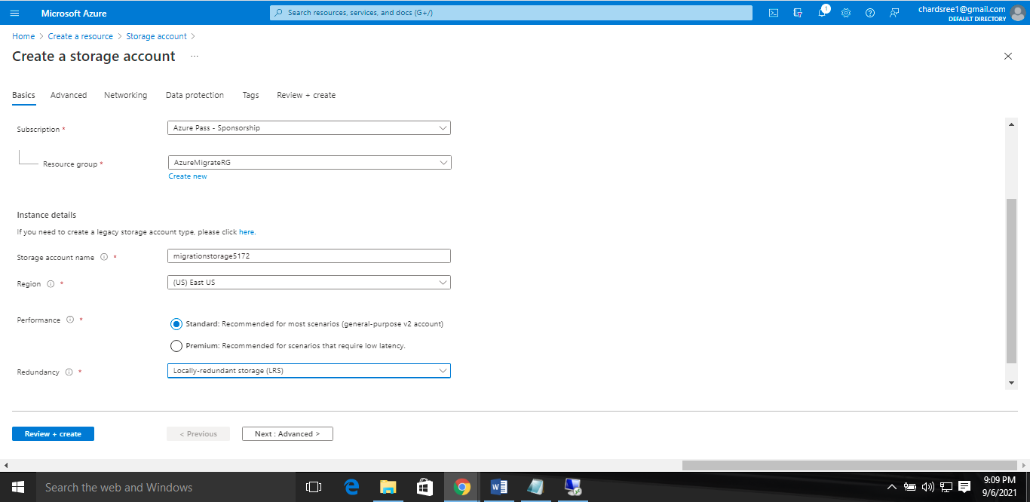

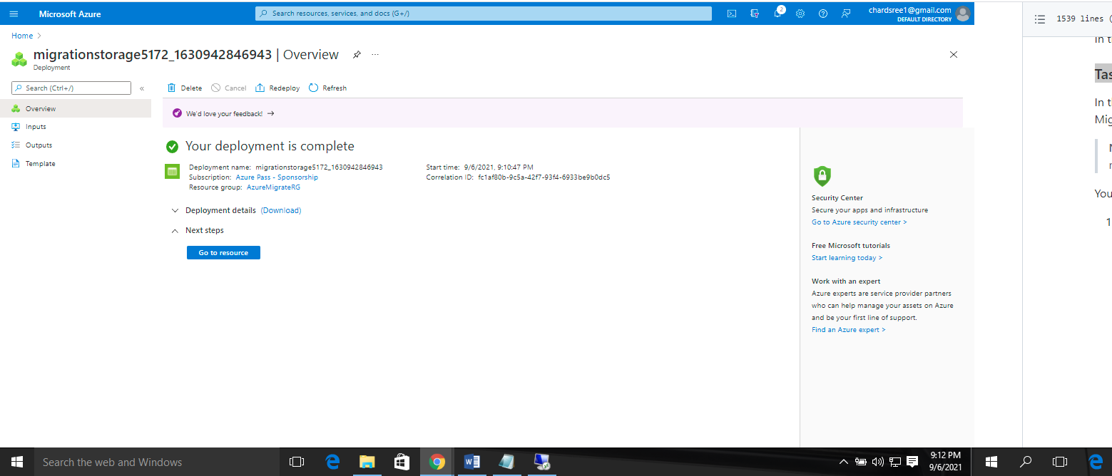

### Task 2: Create a Virtual Network

### 

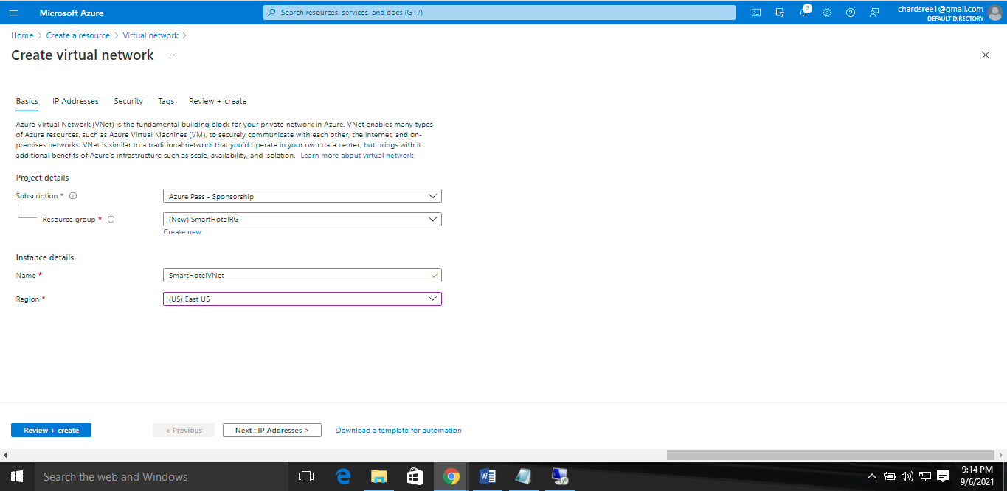

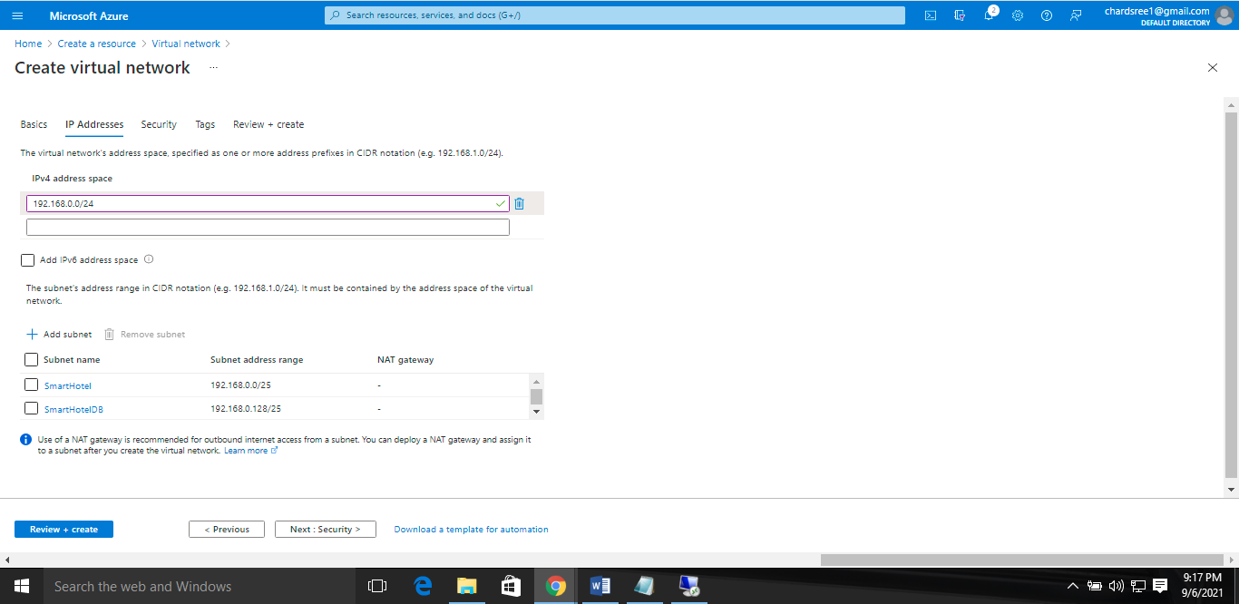

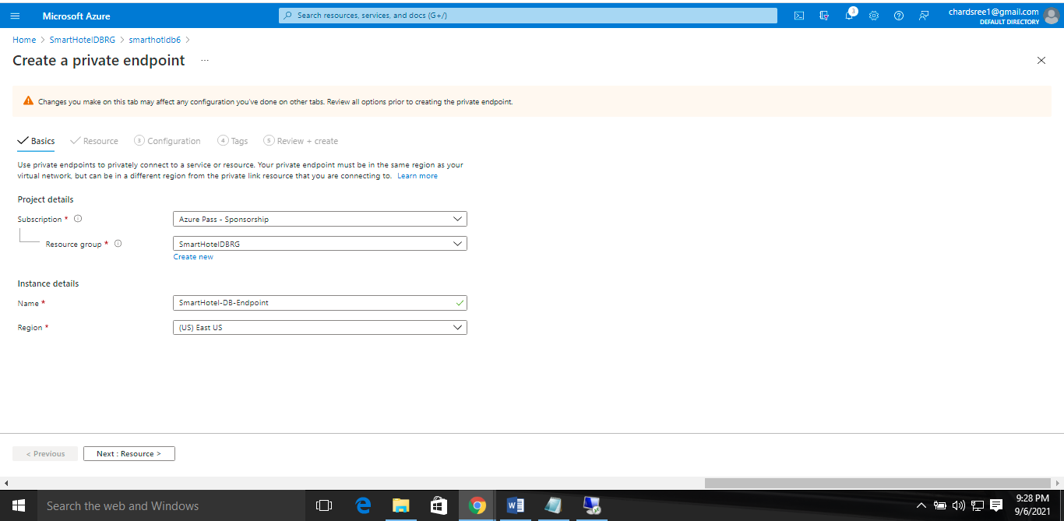

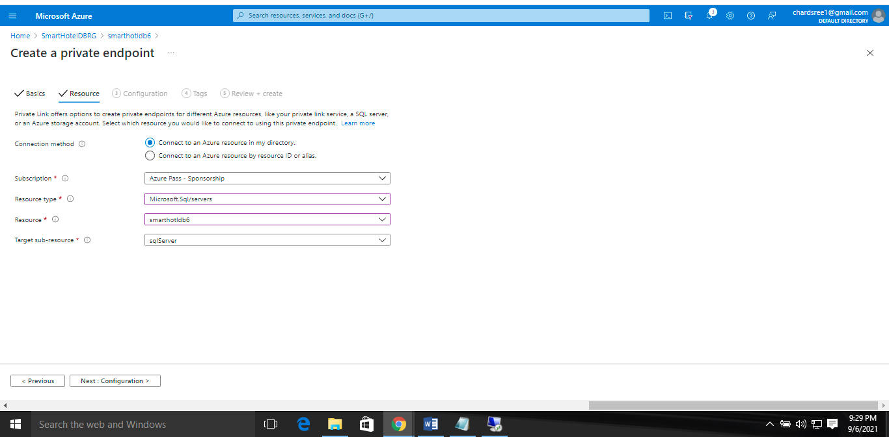

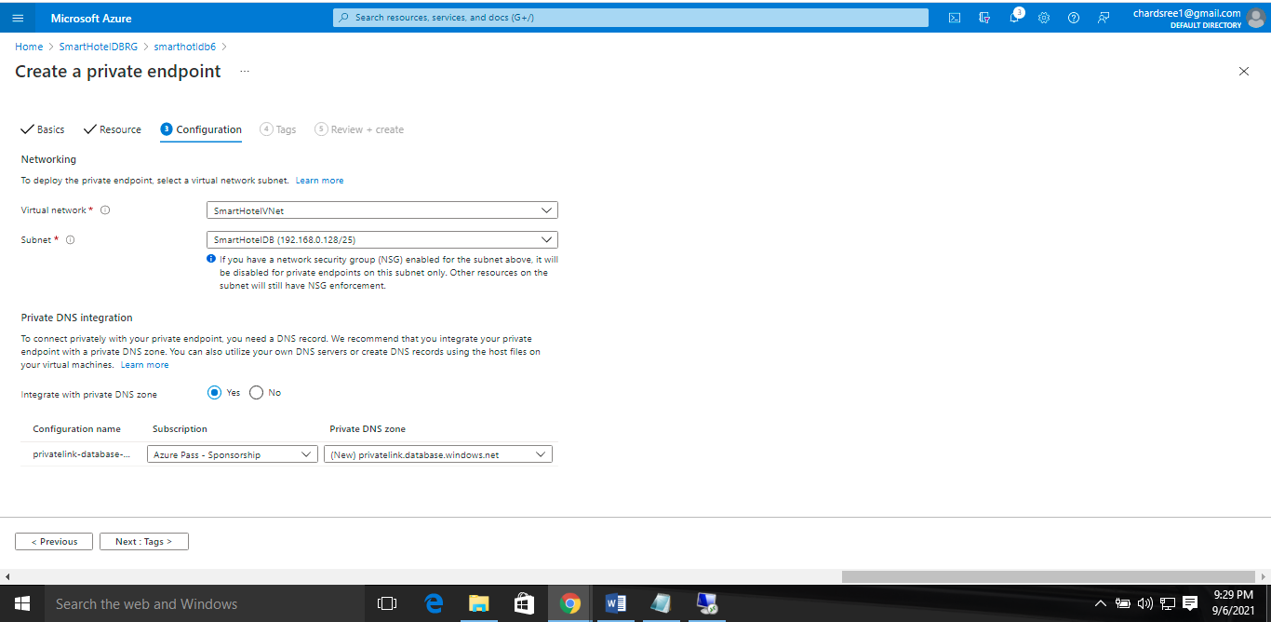

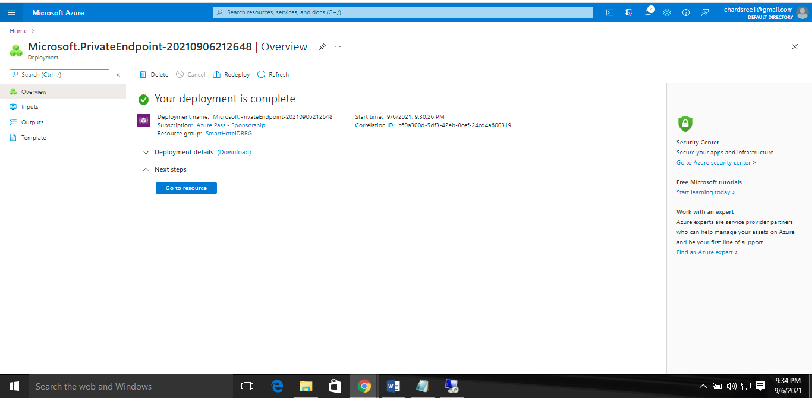

In this task you created a new virtual network that will be used by your virtual machines when they are migrated to Azure. You also created a private endpoint in this network, which will be used to access the SQL database.

### Task 3: Register the Hyper-V Host with Azure Migrate: Server Migration

### 

### Installing Azure Site recovery manager

### 

### 

### 

### 

### 

### In this task you registered your Hyper-V host with the Azure Migrate Server Migration service.

### Task 4: Enable Replication from Hyper-V to Azure Migrate

In this task, you will configure and enable the replication of your on-premises virtual machines from Hyper-V to the Azure Migrate Server Migration service.

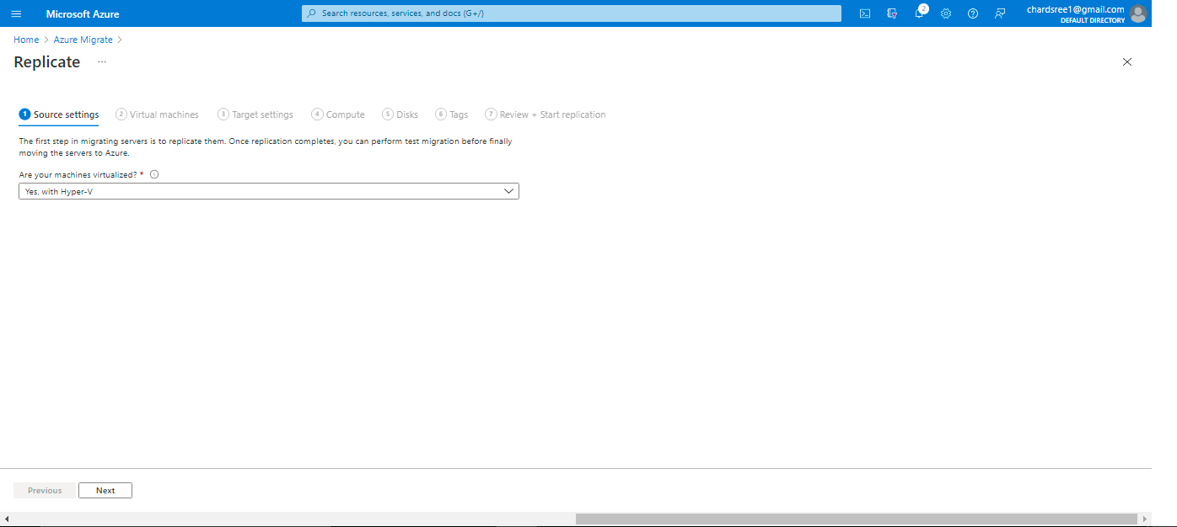

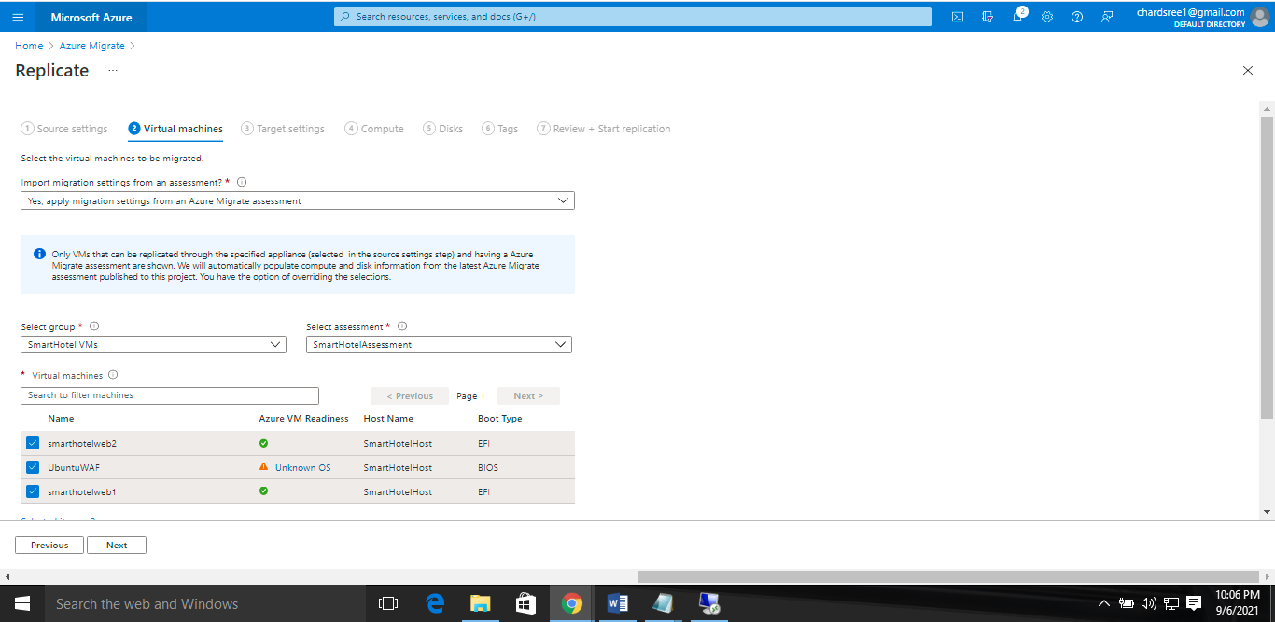

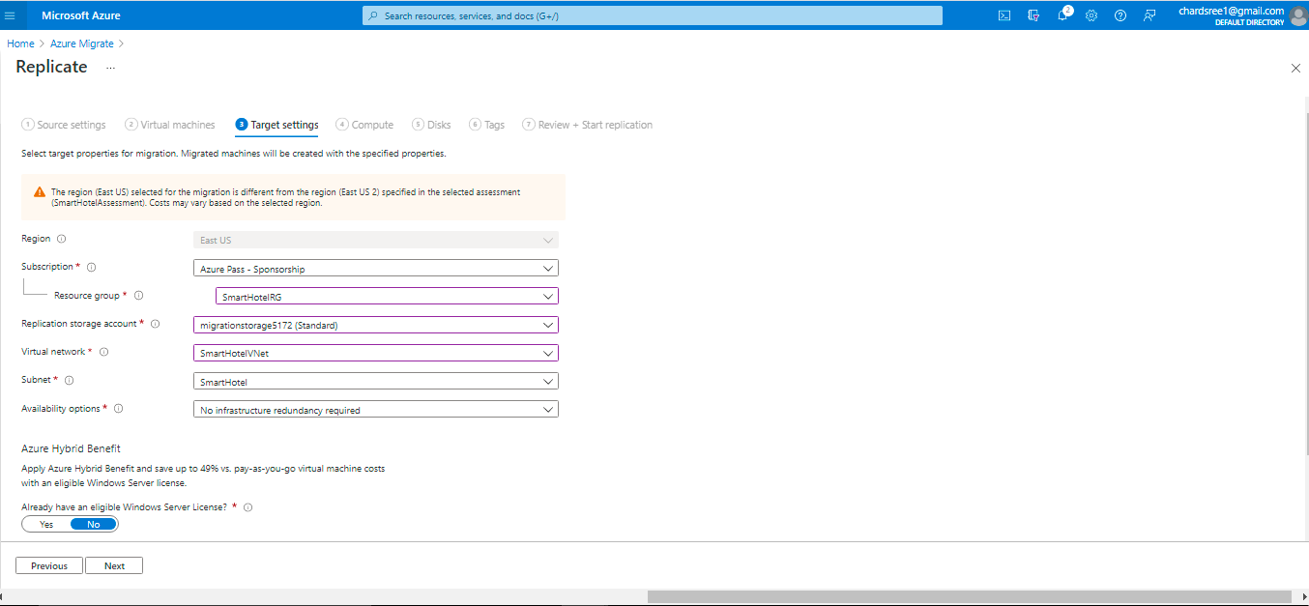

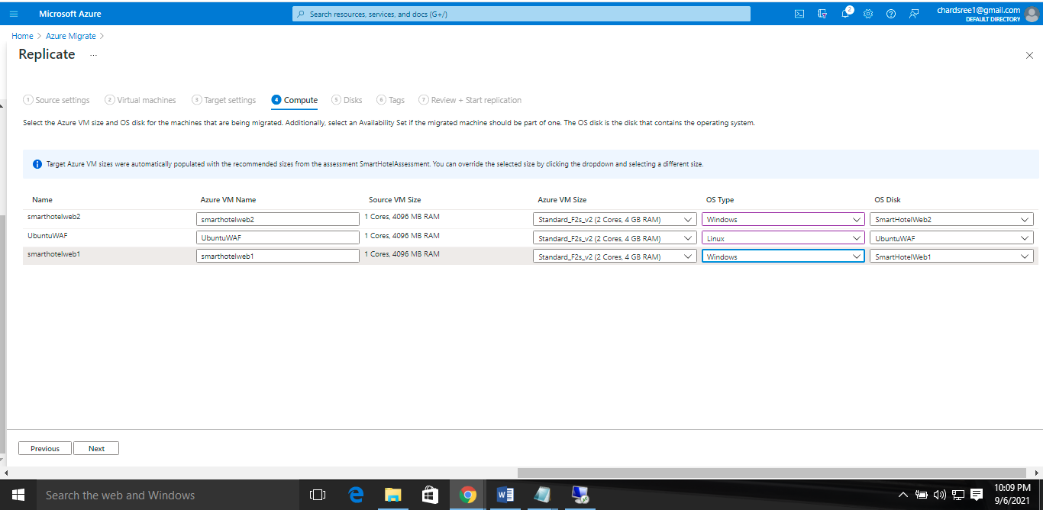

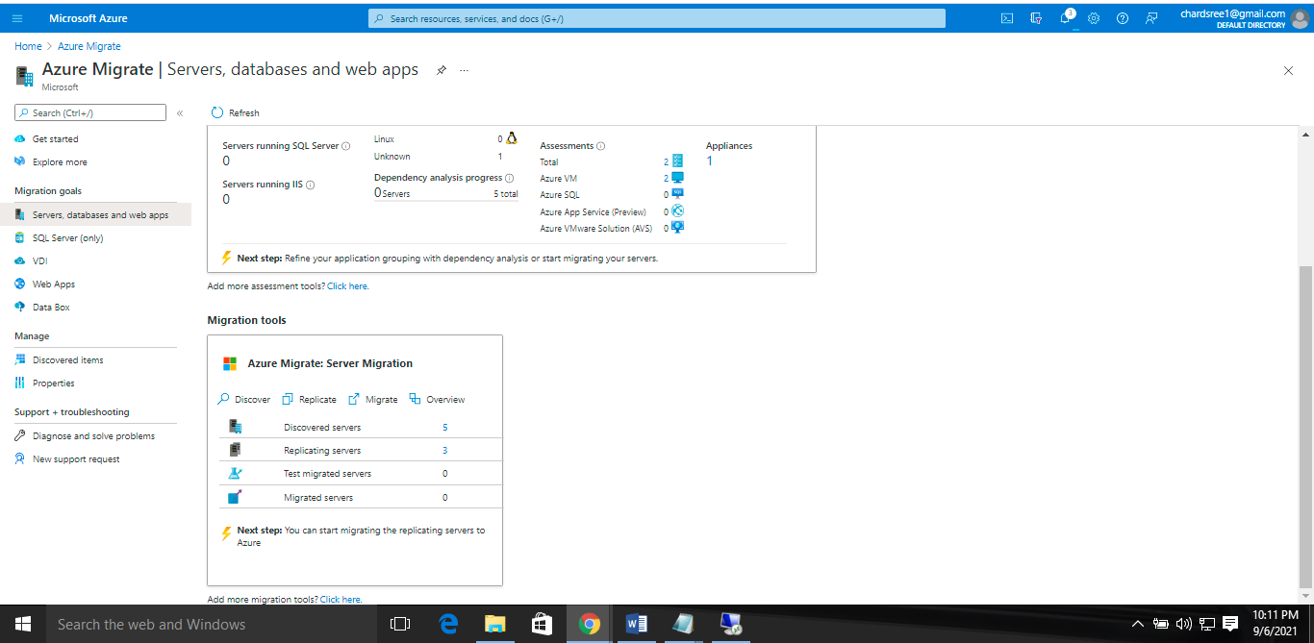

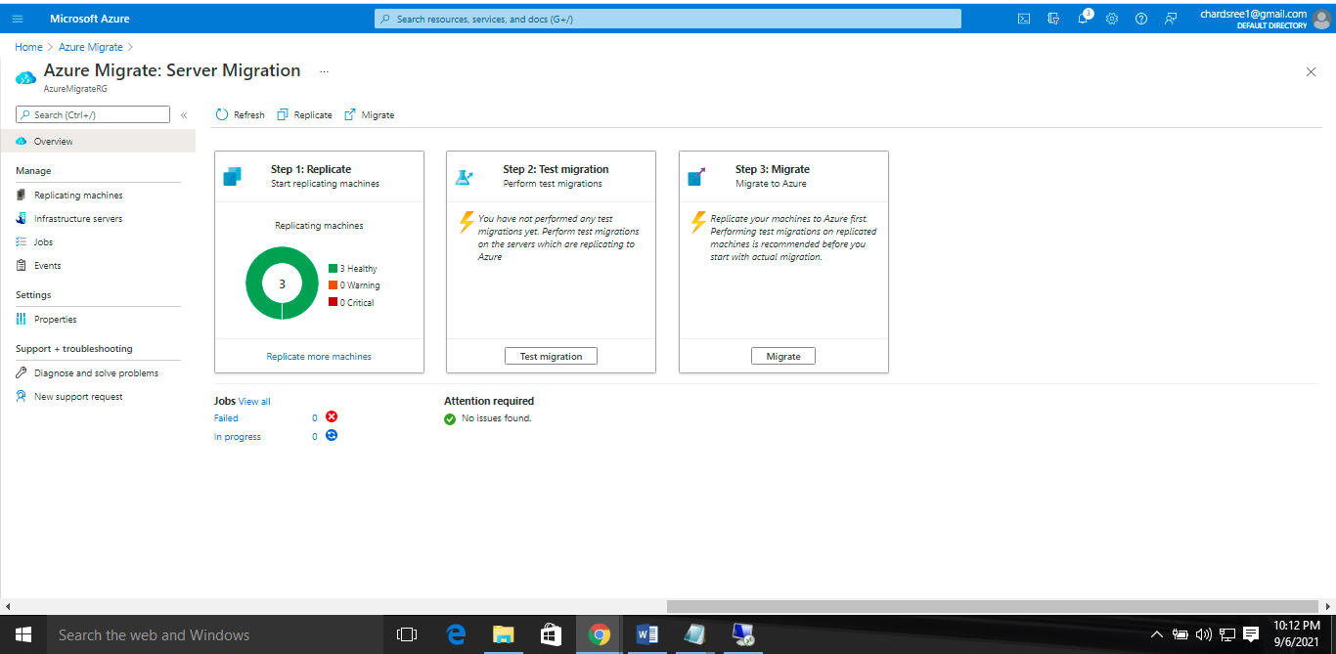

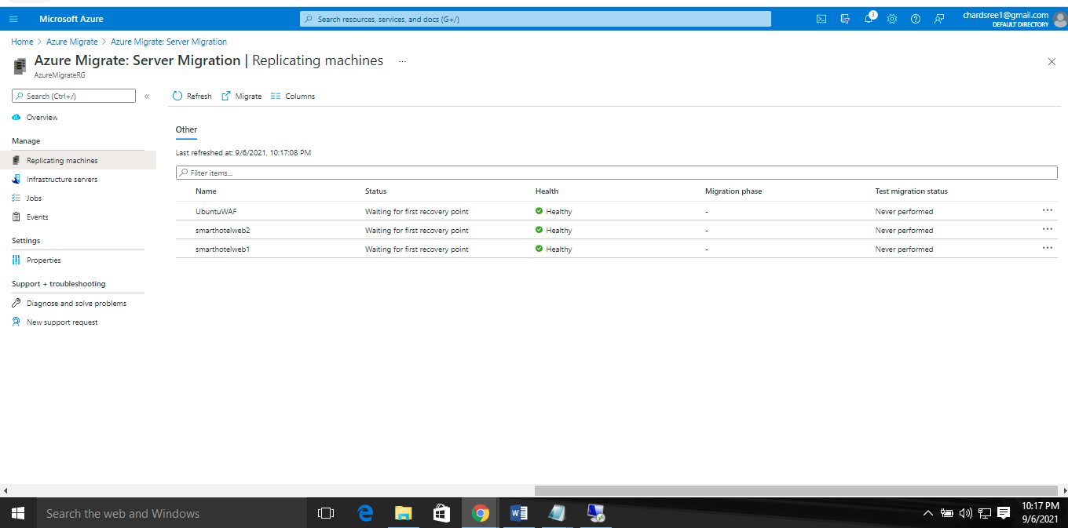

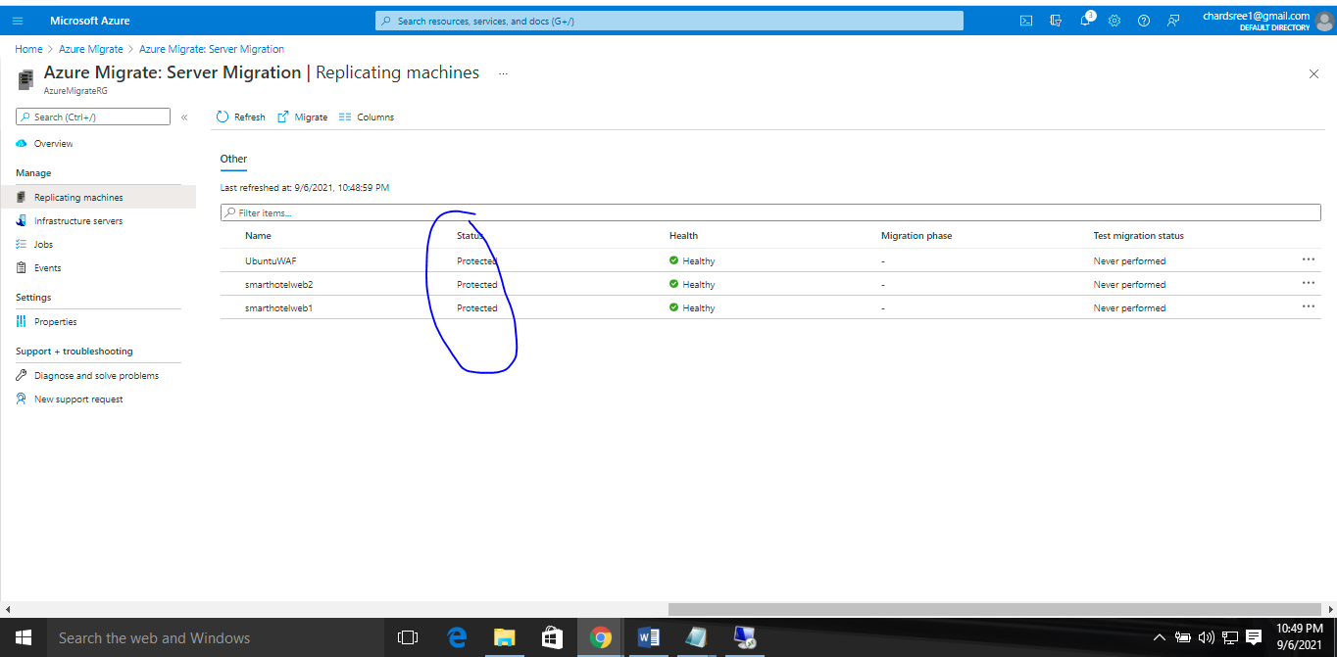

In this task you enabled replication from the Hyper-V host to Azure Migrate, and configured the replicated VM size in Azure.

### Task 5: Configure static internal IP addresses for each VM

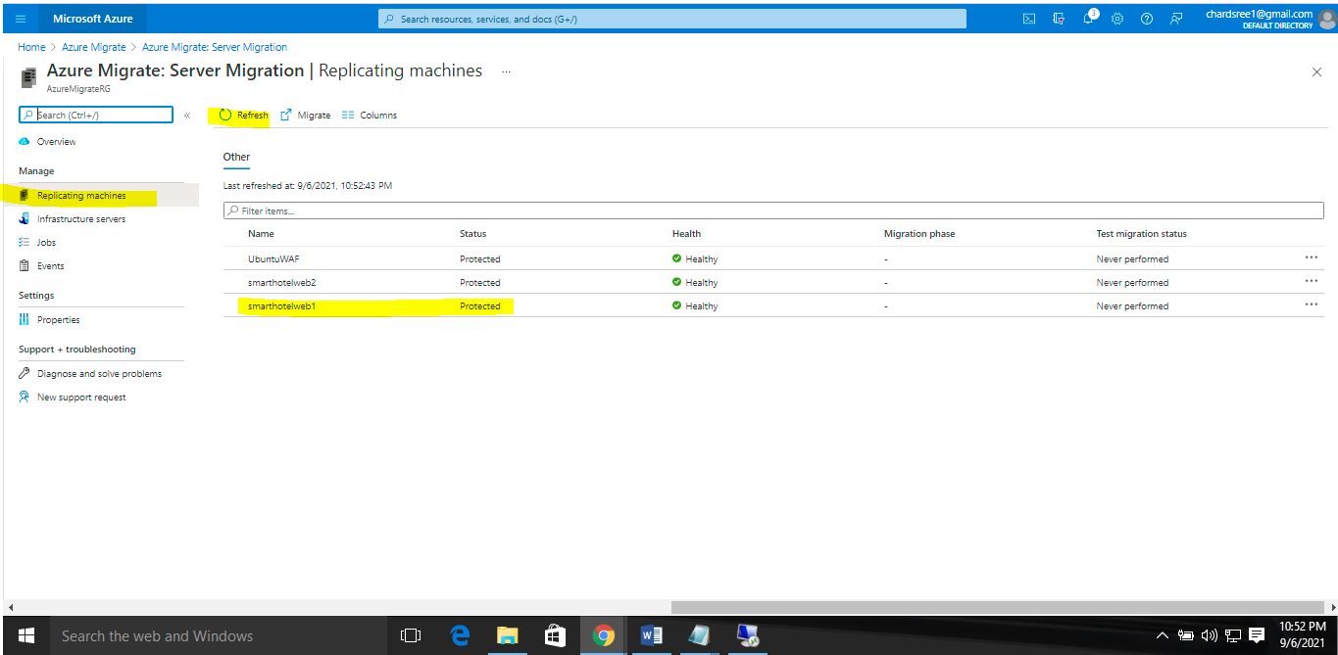

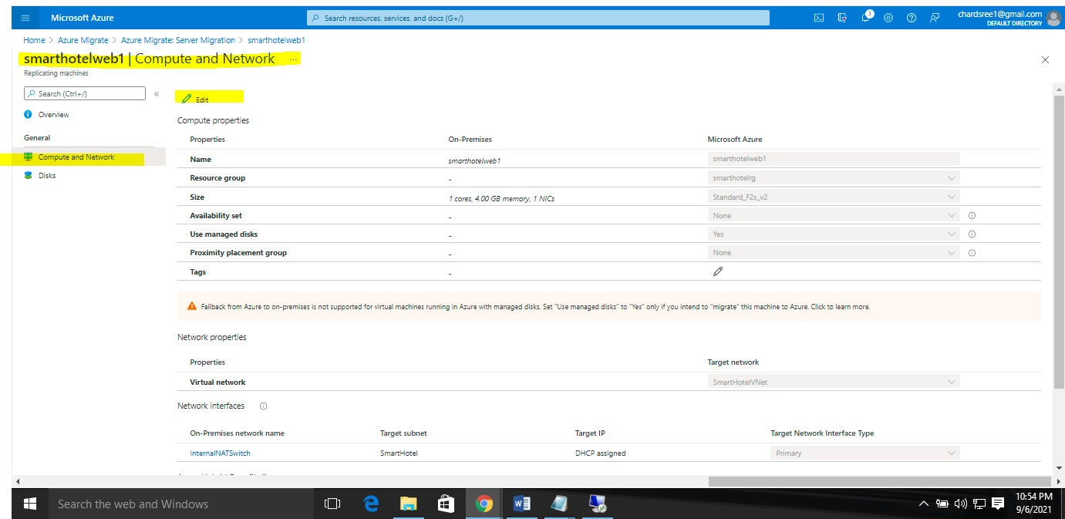

### Task 6: Server migration

In this task we perform a migration of the UbuntuWAF, smarthotelweb1, and smarthotelweb2 machines to Azure.

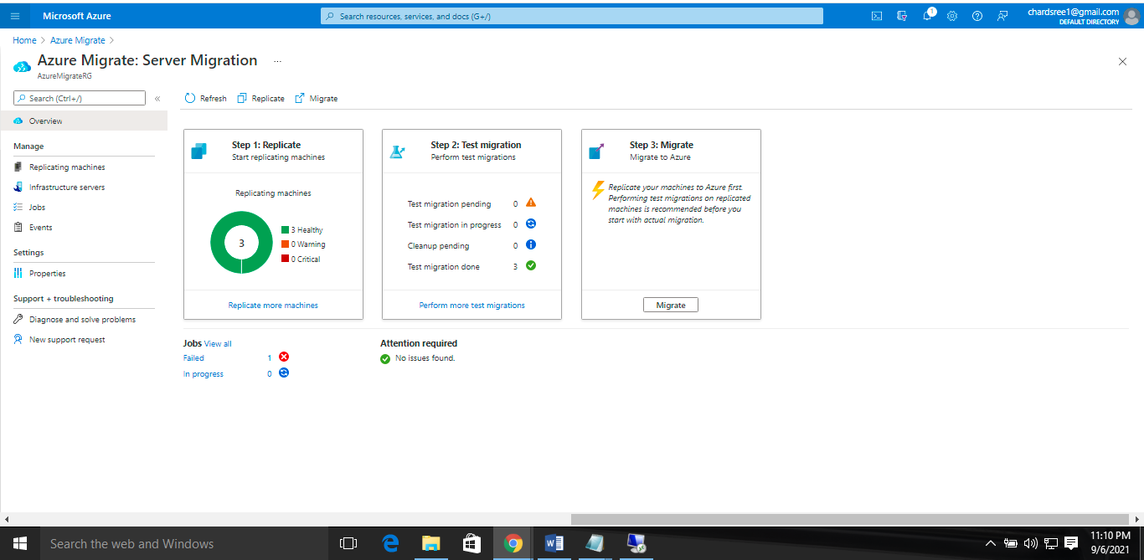

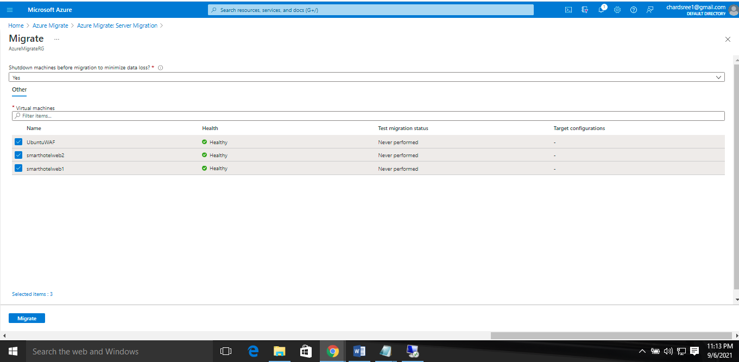

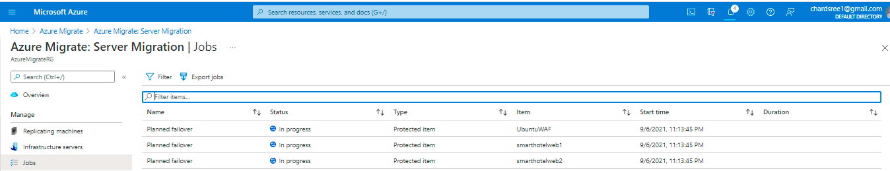

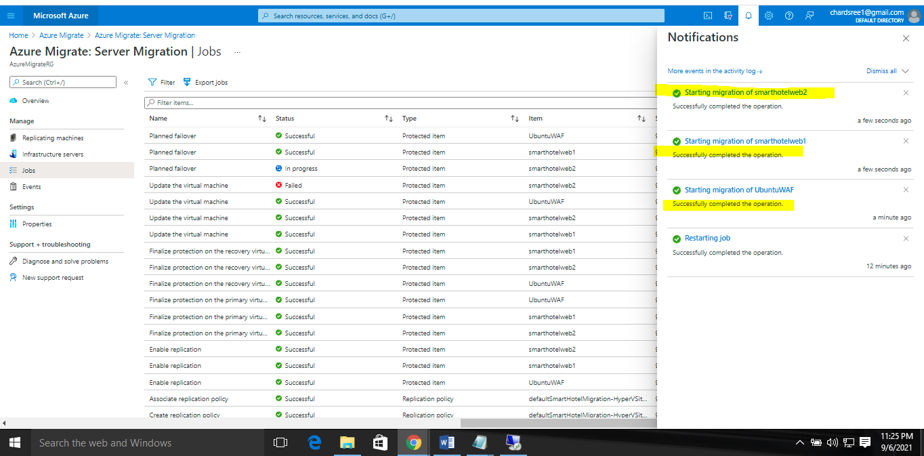

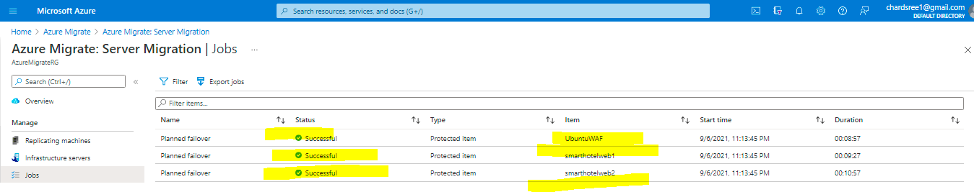

### Task 7: Enable Azure Bastion

To access newly-migrated virtual machines to make some configuration changes. Currently machines do not have public IP.

We will access them using Azure Bastion.

### Task 8: Configure the database connection

